UNITED STATES
SECURITIES AND EXCHANGE COMMISSION

Washington, D.C. 20549

FORM 10-Q
☒ |  |  | QUARTERLY REPORT PURSUANT TO SECTION 13 OR 15(d) OF THE SECURITIES EXCHANGE ACT OF 1934

For the Quarterly Period Ended June 30, 2023

OR
☐ |  |  | TRANSITION REPORT PURSUANT TO SECTION 13 OR 15(d) OF THE SECURITIES EXCHANGE ACT OF 1934

For the Transition Period from __________________ to _________________________

Commission File Number 001-33650

LISATA THERAPEUTICS, INC.
(Exact name of registrant as specified in its charter)

Delaware |  |  | 22-2343568
(State or other jurisdiction of incorporation or organization) |  |  | (I.R.S. Employer Identification No.)
110 Allen Road, 2nd Floor, Basking Ridge, New Jersey |  |  | 07920
(Address of principal executive offices) |  |  | (zip code)

Registrant’s telephone number, including area code: 908-842-0100

Securities registered pursuant to Section 12(b) of the Act:
Title of each class |  |  | Trading Symbol(s) |  |  | Name of each exchange on which registered
Common Stock, par value $0.001 per share |  |  | LSTA |  |  | The Nasdaq Capital Market

Indicate by check mark whether the registrant (1) has filed all reports required to be filed by Section 13 or 15(d) of the Securities Exchange Act of 1934 during the preceding 12 months (or for such shorter period that the registrant was required to file such reports), and (2) has been subject to such filing requirements for the past 90 days. Yes ☒ No ☐
Indicate by check mark whether the registrant has submitted electronically every Interactive Data File required to be submitted pursuant to Rule 405 of Regulation S-T (§ 232.405 of this chapter) during the preceding 12 months (or for such shorter period that the registrant was required to submit and post such files). Yes ☒ No ☐
Indicate by check mark whether the registrant is a large accelerated filer, an accelerated filer, a non-accelerated filer, a smaller reporting company, or an emerging growth company. See definition of “large accelerated filer,” “accelerated filer”, “smaller reporting company” and “emerging growth company” in Rule 12b-2 of the Exchange Act:
Large accelerated filer |  |  | ☐ |  |  |  |  |  | Accelerated filer |  |  | ☐
Non-accelerated filer |  |  | ☒ |  |  |  |  |  | Smaller reporting company |  |  | ☒
 |  |  |  |  |  |  |  |  | Emerging growth company |  |  | ☐
If an emerging growth company, indicate by check mark if the registrant has elected not to use the extended transition period for complying with any new or revised financial accounting standards provided pursuant to Section 13(a) of the Exchange Act. ☐

Indicate by check mark whether the registrant is a shell company (as defined in Rule 12b-2 of the Exchange Act).
Yes ☐ No ☒

Indicate the number of shares outstanding of each of the issuer's classes of common stock, as of the latest practicable date.
Class |  |  | Outstanding as of August 14, 2023
Common stock, $0.001 par value per share |  |  | 8,142,357 |  |  | shares

Index
CAUTIONARY NOTE REGARDING FORWARD-LOOKING STATEMENTS

This quarterly report (this “Quarterly Report”) contains “forward-looking” statements within the meaning of the Private Securities Litigation Reform Act of 1995, as well as historical information. When used in this Quarterly Report, statements that are not statements of current or historical fact may be deemed to be forward-looking statements, including, without limitation, all statements related to any expectations of revenues, expenses, cash flows, earnings or losses from operations, cash required to maintain current and planned operations, capital or other financial items; any statements of the plans, strategies and objectives of management for future operations; any plans or expectations with respect to product research, development and commercialization, including regulatory approvals; any other statements of expectations, plans, intentions or beliefs; and any statements of assumptions underlying any of the foregoing. Without limiting the foregoing, the words “plan,” “project,” “forecast,” “outlook,” “intend,” “may,” “will,” “expect,” “anticipate,” “likely,” “believe,” “could,” “anticipate,” “estimate,” “continue,” “target” or similar expressions or other variations or comparable terminology are intended to identify such forward-looking statements, although some forward-looking statements are expressed differently. We remind readers that forward-looking statements are merely predictions and therefore inherently subject to uncertainties and other factors and involve known and unknown risks that could cause the actual results, performance, levels of activity or our achievements or industry results, to be materially different from any future results, performance, levels of activity or our achievements or industry results expressed or implied by such forward-looking statements. Factors that could cause our actual results to differ materially from anticipated results expressed or implied by forward-looking statements include, among others:
•our ability to obtain sufficient capital or strategic business arrangements to fund our operations and expansion plans, including collecting amounts owed to us under various licensing and other strategic arrangements, meeting our financial obligations under various licensing and other strategic arrangements, the funding of our clinical trials for product candidates, and the commercialization of the relevant technology;
•our ability to build and maintain the management and human resources infrastructure necessary to support the operation and/or growth of our business;
•whether a market is established for our products and our ability to capture a meaningful share of this market;
•scientific, regulatory and medical developments beyond our control;
•our ability to obtain and maintain, as applicable, appropriate governmental licenses, accreditations or certifications or to comply with healthcare laws and regulations or any other adverse effect or limitations caused by government regulation of our business;
•whether any of our current or future patent applications result in issued patents, the scope of those patents and our ability to obtain and maintain other rights to technology required or desirable for the conduct of our business, and our ability to commercialize products without infringing upon the claims of third-party patents;
•whether any potential strategic or financial benefits of various licensing agreements will be realized;
•our ability to diversify our pipeline of development product candidates, which could include an acquisition, merger, business combination, in-license or other strategic transaction, and whether any of such efforts will result in us entering into or completing any transaction or that any such transaction, if completed, will add to shareholder value;
•the long-term success of our recently completed merger with Cend Therapeutics, Inc. (“Cend”), including the ongoing integration of Cend’s operations and the advancement of their development programs;
•the results of our development activities;
•our ability to complete our other planned clinical trials (or initiate other trials) in accordance with our estimated timelines due to delays associated with enrolling patients due to the novelty of the treatment, the size of the patient population, competition with other clinical trials for similar subjects, patient and/or investigator site availability and accessibility due to external macroenvironmental factors such as the COVID-19 pandemic and the need of patients to meet the inclusion criteria of the trial or otherwise;
•the extent to which the COVID-19 pandemic and any future pandemic and/or their long-term effects may impact, directly or indirectly, our business, including our clinical trials and financial condition; and
•other factors discussed in “Risk Factors” in our Annual Report on Form 10-K filed with the Securities and Exchange Commission (the “SEC”) on March 30, 2023 (our “2022 Form 10-K”).
2
Index
The factors discussed herein, including those risks described in “Item 1A. Risk Factors” and elsewhere in our 2022 Form 10-K and in our other periodic filings with the SEC, which are available for review at www.sec.gov, could cause actual results and developments to be materially different from those expressed or implied by such statements. All forward-looking statements attributable to us are expressly qualified in their entirety by these and other factors. Readers are cautioned not to place undue reliance on these forward-looking statements, which speak only as of the date they were made. Except as required by law, we undertake no obligation to update any forward-looking statements, whether as a result of new information, future events or otherwise.

3
Index
TABLE OF CONTENTS
 |  |  | PART I- FINANCIAL INFORMATION |  |  | Page No.
Item 1. |  |  | Financial Statements: |  |  | 5
 |  |  | Consolidated Balance Sheets at June 30, 2023 (unaudited) and December 31, 2022 |  |  | 5
 |  |  | Consolidated Statements of Operations for the three and six months ended June 30, 2023 and 2022 (unaudited) |  |  | 6
 |  |  | Consolidated Statements of Comprehensive Loss for the three and six months ended June 30, 2023 and 2022 (unaudited) |  |  | 7
 |  |  | Consolidated Statements of Equity for the three and six months ended June 30, 2023 and 2022 (unaudited) |  |  | 8
 |  |  | Consolidated Statements of Cash Flows for the six months ended June 30, 2023 and 2022 (unaudited) |  |  | 10
 |  |  | Notes to Unaudited Consolidated Financial Statements |  |  | 11
Item 2. |  |  | Management’s Discussion and Analysis of Financial Condition and Results of Operations |  |  | 26
Item 3. |  |  | Quantitative and Qualitative Disclosures About Market Risk |  |  | 34
Item 4. |  |  | Controls and Procedures |  |  | 34
 |  |  | PART II- OTHER INFORMATION
Item 1. |  |  | Legal Proceedings |  |  | 36
Item 1A. |  |  | Risk Factors |  |  | 36
Item 2. |  |  | Unregistered Sales of Equity Securities and Use of Proceeds |  |  | 36
Item 3. |  |  | Defaults Upon Senior Securities |  |  | 36
Item 4. |  |  | Mine Safety Disclosures |  |  | 36
Item 5. |  |  | Other Information |  |  | 36
Item 6. |  |  | Exhibits |  |  | 36
 |  |  | Signatures |  |  | 37

4
Index
PART I. FINANCIAL INFORMATION

ITEM 1. FINANCIAL STATEMENTS

LISATA THERAPEUTICS, INC. AND SUBSIDIARIES
CONSOLIDATED BALANCE SHEETS
(In thousands, except share data)
 |  |  | June 30,  2023 |  |  |  |  |  | December 31,  2022
ASSETS |  |  | (Unaudited)
Cash and cash equivalents |  |  | $ | 23,690 |  |  |  |  | $ | 32,154
Marketable securities |  |  | 33,936 |  |  |  |  |  | 37,072
Prepaid and other current assets |  |  | 3,797 |  |  |  |  |  | 2,650
Total current assets |  |  | 61,423 |  |  |  |  |  | 71,876
Property and equipment, net |  |  | 233 |  |  |  |  |  | 296
Acquired license - intangible |  |  | 299 |  |  |  |  |  | 334
Other assets |  |  | 410 |  |  |  |  |  | 528
Total assets |  |  | $ | 62,365 |  |  |  |  | $ | 73,034
LIABILITIES AND STOCKHOLDERS' EQUITY
Liabilities
Accounts payable |  |  | $ | 775 |  |  |  |  | $ | 2,655
Accrued liabilities |  |  | 3,581 |  |  |  |  |  | 3,728
Total current liabilities |  |  | 4,356 |  |  |  |  |  | 6,383
Other long-term liabilities |  |  | 295 |  |  |  |  |  | 327
Total liabilities |  |  | 4,651 |  |  |  |  |  | 6,710
Commitments and Contingencies (Note 14)
Stockholders' Equity
Common stock, $0.001 par value, authorized 33,333,333 shares; issued 8,133,095  and 7,866,799 shares at June 30, 2023 and December 31, 2022, respectively; and  outstanding, 8,132,357 and 7,866,061 shares at June 30, 2023 and December 31, 2022,  respectively |  |  | 8 |  |  |  |  |  | 8
Additional paid-in capital |  |  | 576,173 |  |  |  |  |  | 574,548
Treasury stock, at cost; 738 shares at June 30, 2023 and December 31, 2022 |  |  | (708) |  |  |  |  |  | (708)
Accumulated deficit |  |  | (517,455) |  |  |  |  |  | (507,241)
Accumulated other comprehensive loss |  |  | (50) |  |  |  |  |  | (29)
Total Lisata Therapeutics, Inc. stockholders' equity |  |  | 57,968 |  |  |  |  |  | 66,578
Non-controlling interests |  |  | (254) |  |  |  |  |  | (254)
Total stockholders' equity |  |  | 57,714 |  |  |  |  |  | 66,324
Total liabilities, non-controlling interests and stockholders' equity |  |  | $ | 62,365 |  |  |  |  | $ | 73,034
See accompanying notes to consolidated financial statements.
5
Index

LISATA THERAPEUTICS, INC. AND SUBSIDIARIES
CONSOLIDATED STATEMENTS OF OPERATIONS
(Unaudited)
(In thousands, except per share data)
 |  |  | Three Months Ended June 30, |  |  |  |  |  |  |  |  |  |  |  | Six Months Ended June 30,
 |  |  | 2023 |  |  |  |  |  | 2022 |  |  |  |  |  | 2023 |  |  |  |  |  | 2022
Operating Expenses:
Research and development |  |  | $ | 3,162 |  |  |  |  | $ | 3,234 |  |  |  |  | $ | 6,341 |  |  |  |  | $ | 6,516
General and administrative |  |  | 3,713 |  |  |  |  |  | 3,486 |  |  |  |  |  | 7,378 |  |  |  |  |  | 6,824
Total operating expenses |  |  | 6,875 |  |  |  |  |  | 6,720 |  |  |  |  |  | 13,719 |  |  |  |  |  | 13,340
Operating loss |  |  | (6,875) |  |  |  |  |  | (6,720) |  |  |  |  |  | (13,719) |  |  |  |  |  | (13,340)
Other income (expense):
Investment income, net |  |  | 668 |  |  |  |  |  | 94 |  |  |  |  |  | 1,338 |  |  |  |  |  | 158
Other expense, net |  |  | (150) |  |  |  |  |  | — |  |  |  |  |  | (163) |  |  |  |  |  | (149)
Total other income (expense) |  |  | 518 |  |  |  |  |  | 94 |  |  |  |  |  | 1,175 |  |  |  |  |  | 9
Net loss before benefit from income taxes and noncontrolling interests |  |  | (6,357) |  |  |  |  |  | (6,626) |  |  |  |  |  | (12,544) |  |  |  |  |  | (13,331)
Benefit from income taxes |  |  | (2,330) |  |  |  |  |  | — |  |  |  |  |  | (2,330) |  |  |  |  |  | (2,479)
Net loss |  |  | $ | (4,027) |  |  |  |  | $ | (6,626) |  |  |  |  | $ | (10,214) |  |  |  |  | $ | (10,852)
Less - net income attributable to noncontrolling interests |  |  | — |  |  |  |  |  | — |  |  |  |  |  | — |  |  |  |  |  | —
Net loss attributable to Lisata Therapeutics, Inc. common stockholders |  |  | $ | (4,027) |  |  |  |  | $ | (6,626) |  |  |  |  | $ | (10,214) |  |  |  |  | $ | (10,852)
Basic and diluted loss per share
Lisata Therapeutics, Inc. common stockholders |  |  | $ | (0.50) |  |  |  |  | $ | (1.64) |  |  |  |  | $ | (1.28) |  |  |  |  | $ | (2.69)
Weighted average common shares outstanding
Basic and diluted shares |  |  | 8,021 |  |  |  |  |  | 4,035 |  |  |  |  |  | 8,004 |  |  |  |  |  | 4,036

See accompanying notes to consolidated financial statements.

6
Index
LISATA THERAPEUTICS, INC. AND SUBSIDIARIES
CONSOLIDATED STATEMENTS OF COMPREHENSIVE LOSS
(Unaudited)
(In thousands)
 |  |  | Three Months Ended June 30, |  |  |  |  |  |  |  |  |  |  |  | Six Months Ended June 30,
 |  |  | 2023 |  |  |  |  |  | 2022 |  |  |  |  |  | 2023 |  |  |  |  |  | 2022
Net loss |  |  | $ | (4,027) |  |  |  |  | $ | (6,626) |  |  |  |  | $ | (10,214) |  |  |  |  | $ | (10,852)
Other comprehensive loss:
Available for sale securities - net unrealized gain |  |  | 12 |  |  |  |  |  | 126 |  |  |  |  |  | 1 |  |  |  |  |  | —
Cumulative translation adjustment arising during the period |  |  | (10) |  |  |  |  |  | — |  |  |  |  |  | (22) |  |  |  |  |  | —
Total other comprehensive loss |  |  | 2 |  |  |  |  |  | 126 |  |  |  |  |  | (21) |  |  |  |  |  | —
Comprehensive loss attributable to Lisata Therapeutics, Inc. common  stockholders |  |  | $ | (4,025) |  |  |  |  | $ | (6,500) |  |  |  |  | $ | (10,235) |  |  |  |  | $ | (10,852)

See accompanying notes to consolidated financial statements.

7
Index
LISATA THERAPEUTICS, INC. AND SUBSIDIARIES
CONSOLIDATED STATEMENTS OF EQUITY
(Unaudited)
(In thousands)
 |  |  |  |  | Common Stock |  |  |  |  |  |  |  |  |  | Additional  Paid-in  Capital |  |  |  |  |  | Accumulated  Other  Comprehensive  Loss |  |  |  |  |  | Accumulated  Deficit |  |  |  |  |  | Treasury  Stock |  |  |  |  |  | Total  Lisata Therapeutics,  Inc.  Stockholders'  Equity |  |  |  |  |  | Non-  Controlling  Interest in  Subsidiary |  |  |  |  |  | Total  Equity
 |  |  |  |  |  |  |  |  | Shares |  |  |  |  |  |  |  |  | Amount
Balance at March 31, 2022 |  |  |  |  |  |  |  |  | 4,035 |  |  |  |  |  | $ | 4 |  |  |  |  | $ | 546,637 |  |  |  |  | $ | (196) |  |  |  |  | $ | (457,242) |  |  |  |  | $ | (708) |  |  |  |  | $ | 88,495 |  |  |  |  | $ | (254) |  |  |  |  | $ | 88,241
Net loss |  |  |  |  |  |  |  |  | — |  |  |  |  |  | — |  |  |  |  |  | — |  |  |  |  |  | — |  |  |  |  |  | (6,626) |  |  |  |  |  | — |  |  |  |  |  | (6,626) |  |  |  |  |  | — |  |  |  |  |  | (6,626)
Share-based compensation |  |  |  |  |  |  |  |  | (1) |  |  |  |  |  | — |  |  |  |  |  | 367 |  |  |  |  |  | — |  |  |  |  |  | — |  |  |  |  |  | — |  |  |  |  |  | 367 |  |  |  |  |  | — |  |  |  |  |  | 367
Proceeds from issuance of common stock |  |  |  |  |  |  |  |  | 4 |  |  |  |  |  | — |  |  |  |  |  | 29 |  |  |  |  |  | — |  |  |  |  |  | — |  |  |  |  |  | — |  |  |  |  |  | 29 |  |  |  |  |  | — |  |  |  |  |  | 29
Unrealized gain on marketable securities |  |  |  |  |  |  |  |  | — |  |  |  |  |  | — |  |  |  |  |  | — |  |  |  |  |  | 126 |  |  |  |  |  | — |  |  |  |  |  | — |  |  |  |  |  | 126 |  |  |  |  |  | — |  |  |  |  |  | 126
Balance at June 30, 2022 |  |  |  |  |  |  |  |  | 4,038 |  |  |  |  |  | $ | 4 |  |  |  |  | $ | 547,033 |  |  |  |  | $ | (70) |  |  |  |  | $ | (463,868) |  |  |  |  | $ | (708) |  |  |  |  | $ | 82,391 |  |  |  |  | $ | (254) |  |  |  |  | $ | 82,137
 |  |  |  |  | Common Stock |  |  |  |  |  |  |  |  |  | Additional  Paid-in  Capital |  |  |  |  |  | Accumulated  Other  Comprehensive Loss |  |  |  |  |  | Accumulated  Deficit |  |  |  |  |  | Treasury  Stock |  |  |  |  |  | Total  Lisata Therapeutics,  Inc.  Stockholders'  Equity |  |  |  |  |  | Non-  Controlling  Interest in  Subsidiary |  |  |  |  |  | Total  Equity
 |  |  |  |  |  |  |  |  | Shares |  |  |  |  |  |  |  |  | Amount
Balance at December 31, 2021 |  |  |  |  |  |  |  |  | 3,986 |  |  |  |  |  | $ | 4 |  |  |  |  | $ | 546,044 |  |  |  |  | $ | (70) |  |  |  |  | $ | (453,016) |  |  |  |  | $ | (708) |  |  |  |  | $ | 92,254 |  |  |  |  | $ | (254) |  |  |  |  | $ | 92,000
Net loss |  |  |  |  |  |  |  |  | — |  |  |  |  |  | — |  |  |  |  |  | — |  |  |  |  |  | — |  |  |  |  |  | (10,852) |  |  |  |  |  | — |  |  |  |  |  | (10,852) |  |  |  |  |  | — |  |  |  |  |  | (10,852)
Share-based compensation |  |  |  |  |  |  |  |  | 48 |  |  |  |  |  | — |  |  |  |  |  | 960 |  |  |  |  |  | — |  |  |  |  |  | — |  |  |  |  |  | — |  |  |  |  |  | 960 |  |  |  |  |  | — |  |  |  |  |  | 960
Net proceeds from issuances of common stock |  |  |  |  |  |  |  |  | 4 |  |  |  |  |  | — |  |  |  |  |  | 29 |  |  |  |  |  | — |  |  |  |  |  | — |  |  |  |  |  | — |  |  |  |  |  | 29 |  |  |  |  |  | — |  |  |  |  |  | 29
Balance at June 30, 2022 |  |  |  |  |  |  |  |  | 4,038 |  |  |  |  |  | $ | 4 |  |  |  |  | $ | 547,033 |  |  |  |  | $ | (70) |  |  |  |  | $ | (463,868) |  |  |  |  | $ | (708) |  |  |  |  | $ | 82,391 |  |  |  |  | $ | (254) |  |  |  |  | $ | 82,137

8
Index
 |  |  |  |  | Common Stock |  |  |  |  |  |  |  |  |  | Additional  Paid-in  Capital |  |  |  |  |  | Accumulated  Other  Comprehensive  Loss |  |  |  |  |  | Accumulated  Deficit |  |  |  |  |  | Treasury  Stock |  |  |  |  |  | Total  Lisata Therapeutics,  Inc.  Stockholders'  Equity |  |  |  |  |  | Non-  Controlling  Interest in  Subsidiary |  |  |  |  |  | Total  Equity
 |  |  |  |  |  |  |  |  | Shares |  |  |  |  |  |  |  |  | Amount
Balance at March 31, 2023 |  |  |  |  |  |  |  |  | 7,999 |  |  |  |  |  | $ | 8 |  |  |  |  | $ | 575,137 |  |  |  |  | $ | (52) |  |  |  |  | $ | (513,428) |  |  |  |  | $ | (708) |  |  |  |  | $ | 60,957 |  |  |  |  | $ | (254) |  |  |  |  | $ | 60,703
Net loss |  |  |  |  |  |  |  |  | — |  |  |  |  |  | — |  |  |  |  |  | — |  |  |  |  |  | — |  |  |  |  |  | (4,027) |  |  |  |  |  | — |  |  |  |  |  | (4,027) |  |  |  |  |  | — |  |  |  |  |  | (4,027)
Share-based compensation |  |  |  |  |  |  |  |  | (25) |  |  |  |  |  | — |  |  |  |  |  | 584 |  |  |  |  |  | — |  |  |  |  |  | — |  |  |  |  |  | — |  |  |  |  |  | 584 |  |  |  |  |  | — |  |  |  |  |  | 584
Net proceeds from issuances of common stock |  |  |  |  |  |  |  |  | 76 |  |  |  |  |  | — |  |  |  |  |  | 297 |  |  |  |  |  | — |  |  |  |  |  | — |  |  |  |  |  | — |  |  |  |  |  | 297 |  |  |  |  |  | — |  |  |  |  |  | 297
Proceeds from option exercises |  |  |  |  |  |  |  |  | 83 |  |  |  |  |  | — |  |  |  |  |  | 155 |  |  |  |  |  | — |  |  |  |  |  | — |  |  |  |  |  | — |  |  |  |  |  | 155 |  |  |  |  |  | — |  |  |  |  |  | 155
Foreign Currency Translation Adjustment |  |  |  |  |  |  |  |  | — |  |  |  |  |  | — |  |  |  |  |  | — |  |  |  |  |  | (10) |  |  |  |  |  | — |  |  |  |  |  | — |  |  |  |  |  | (10) |  |  |  |  |  | — |  |  |  |  |  | (10)
Unrealized gain on marketable securities |  |  |  |  |  |  |  |  | — |  |  |  |  |  | — |  |  |  |  |  | — |  |  |  |  |  | 12 |  |  |  |  |  | — |  |  |  |  |  | — |  |  |  |  |  | 12 |  |  |  |  |  | — |  |  |  |  |  | 12
Balance at June 30, 2023 |  |  |  |  |  |  |  |  | 8,133 |  |  |  |  |  | $ | 8 |  |  |  |  | $ | 576,173 |  |  |  |  | $ | (50) |  |  |  |  | $ | (517,455) |  |  |  |  | $ | (708) |  |  |  |  | $ | 57,968 |  |  |  |  | $ | (254) |  |  |  |  | $ | 57,714
 |  |  |  |  | Common Stock |  |  |  |  |  |  |  |  |  | Additional  Paid-in  Capital |  |  |  |  |  | Accumulated  Other  Comprehensive Loss |  |  |  |  |  | Accumulated  Deficit |  |  |  |  |  | Treasury  Stock |  |  |  |  |  | Total  Lisata Therapeutics,  Inc.  Stockholders'  Equity |  |  |  |  |  | Non-  Controlling  Interest in  Subsidiary |  |  |  |  |  | Total  Equity
 |  |  |  |  |  |  |  |  | Shares |  |  |  |  |  |  |  |  | Amount
Balance at December 31, 2022 |  |  |  |  |  |  |  |  | 7,867 |  |  |  |  |  | $ | 8 |  |  |  |  | $ | 574,548 |  |  |  |  | $ | (29) |  |  |  |  | $ | (507,241) |  |  |  |  | $ | (708) |  |  |  |  | $ | 66,578 |  |  |  |  | $ | (254) |  |  |  |  | $ | 66,324
Net loss |  |  |  |  |  |  |  |  | — |  |  |  |  |  | — |  |  |  |  |  | — |  |  |  |  |  | — |  |  |  |  |  | (10,214) |  |  |  |  |  | — |  |  |  |  |  | (10,214) |  |  |  |  |  | — |  |  |  |  |  | (10,214)
Share-based compensation |  |  |  |  |  |  |  |  | 107 |  |  |  |  |  | — |  |  |  |  |  | 1,173 |  |  |  |  |  | — |  |  |  |  |  | — |  |  |  |  |  | — |  |  |  |  |  | 1,173 |  |  |  |  |  | — |  |  |  |  |  | 1,173
Net proceeds from issuances of common stock |  |  |  |  |  |  |  |  | 76 |  |  |  |  |  | — |  |  |  |  |  | 297 |  |  |  |  |  | — |  |  |  |  |  | — |  |  |  |  |  | — |  |  |  |  |  | 297 |  |  |  |  |  | — |  |  |  |  |  | 297
Proceeds from option exercises |  |  |  |  |  |  |  |  | 83 |  |  |  |  |  | — |  |  |  |  |  | 155 |  |  |  |  |  | — |  |  |  |  |  | — |  |  |  |  |  | — |  |  |  |  |  | 155 |  |  |  |  |  | — |  |  |  |  |  | 155
Foreign currency translation adjustment |  |  |  |  |  |  |  |  | — |  |  |  |  |  | — |  |  |  |  |  | — |  |  |  |  |  | (22) |  |  |  |  |  | — |  |  |  |  |  | — |  |  |  |  |  | (22) |  |  |  |  |  | — |  |  |  |  |  | (22)
Unrealized gain on marketable securities |  |  |  |  |  |  |  |  | — |  |  |  |  |  | — |  |  |  |  |  | — |  |  |  |  |  | 1 |  |  |  |  |  | — |  |  |  |  |  | — |  |  |  |  |  | 1 |  |  |  |  |  | — |  |  |  |  |  | 1
Balance at June 30, 2023 |  |  |  |  |  |  |  |  | 8,133 |  |  |  |  |  | $ | 8 |  |  |  |  | $ | 576,173 |  |  |  |  | $ | (50) |  |  |  |  | $ | (517,455) |  |  |  |  | $ | (708) |  |  |  |  | $ | 57,968 |  |  |  |  | $ | (254) |  |  |  |  | $ | 57,714
See accompanying notes to consolidated financial statements.

9
Index
LISATA THERAPEUTICS, INC. AND SUBSIDIARIES
CONSOLIDATED STATEMENTS OF CASH FLOWS
(Unaudited)
(In thousands)

 |  |  | Six Months Ended June 30,
 |  |  | 2023 |  |  |  |  |  | 2022
Cash flows from operating activities:
Net loss |  |  | $ | (10,214) |  |  |  |  | $ | (10,852)
Adjustments to reconcile net loss to net cash used in operating activities:
Share-based compensation |  |  | 1,258 |  |  |  |  |  | 1,128
Depreciation and amortization |  |  | 95 |  |  |  |  |  | 14
Loss on disposal of fixed assets |  |  | 3 |  |  |  |  |  | —
Accretion on marketable securities |  |  | (426) |  |  |  |  |  | 900
Changes in operating assets and liabilities:
Prepaid and other current assets |  |  | (1,161) |  |  |  |  |  | (744)
Other assets |  |  | 117 |  |  |  |  |  | 118
Accounts payable, accrued liabilities and other liabilities |  |  | (2,052) |  |  |  |  |  | (1,268)
Net cash used in operating activities |  |  | (12,380) |  |  |  |  |  | (10,704)
Cash flows from investing activities:
Purchase of marketable securities |  |  | (60,836) |  |  |  |  |  | (30,291)
Sale of marketable securities |  |  | 64,400 |  |  |  |  |  | 60,070
Investment in Cend Therapeutics |  |  | — |  |  |  |  |  | (10,000)
Purchase of property and equipment |  |  | — |  |  |  |  |  | (235)
Net cash provided by investing activities |  |  | 3,564 |  |  |  |  |  | 19,544
Cash flows from financing activities:
Proceeds from exercise of options |  |  | 155 |  |  |  |  |  | —
Tax withholding payments on net share settlement equity awards |  |  | (85) |  |  |  |  |  | (168)
Net proceeds from issuance of common stock |  |  | 297 |  |  |  |  |  | 29
Net cash provided by (used in) financing activities |  |  | 367 |  |  |  |  |  | (139)
Effect of exchange rate changes on cash |  |  | (15) |  |  |  |  |  | —
Net (decrease) increase in cash and cash equivalents |  |  | (8,464) |  |  |  |  |  | 8,701
Cash and cash equivalents at beginning of period |  |  | 32,154 |  |  |  |  |  | 24,647
Cash and cash equivalents at end of period |  |  | $ | 23,690 |  |  |  |  | $ | 33,348
See accompanying notes to consolidated financial statements.

10
Index
LISATA THERAPEUTICS, INC. AND SUBSIDIARIES

NOTES TO UNAUDITED CONSOLIDATED FINANCIAL STATEMENTS

Note 1 – The Business
Overview
Lisata Therapeutics, Inc. (together with its subsidiaries, the “Company”) is a clinical-stage pharmaceutical company dedicated to the discovery, development, and commercialization of innovative therapies for the treatment of solid tumors and other major diseases. The Company's lead investigational product candidate, LSTA1, is designed to activate a novel uptake pathway that allows co-administered or tethered anti-cancer drugs to penetrate solid tumors more effectively. LSTA1 actuates this active transport system in a tumor-specific manner, resulting in systemically co-administered anti-cancer drugs more efficiently penetrating and accumulating in the tumor, while normal tissues are not expected to be affected. LSTA1 also has the potential to modify the tumor microenvironment (“TME”), thereby making tumors more susceptible to immunotherapies. The Company and its collaborators have amassed significant non-clinical data demonstrating enhanced delivery of a range of existing and emerging anti-cancer therapies, including chemotherapeutics, immunotherapies and RNA-based therapeutics. To date, LSTA1 has also demonstrated favorable safety, tolerability and activity in completed and ongoing clinical trials designed to enhance delivery of standard-of-care chemotherapy for pancreatic cancer. The Company is exploring the potential of LSTA1 to enable a variety of treatment modalities to treat a range of solid tumors more effectively. In addition, the Company has development programs based on its autologous CD34+ cell therapy technology platform that it is seeking to partner while incurring no additional capital outlay.
The Company's leadership team has decades of collective biopharmaceutical and pharmaceutical product development experience across a variety of therapeutic categories and at all stages of development from preclinical through to product registration and launch. Its goal is to develop and commercialize products that address important unmet medical needs. The Company’s current development pipeline includes:
•LSTA1, the subject of Phase 1b/2a and 2b clinical studies being conducted globally in a variety of solid tumor types, including metastatic pancreatic ductal adenocarcinoma (mPDAC), in combination with a variety of anti-cancer regimens.
Merger with Cend Therapeutics, Inc. and Name Change
On September 15, 2022, the Company, then operating as Caladrius Biosciences, Inc. (“Caladrius”), completed its acquisition of Cend Therapeutics, Inc. (“Cend”), a Delaware corporation (the “Merger”), in accordance with the terms of the Agreement and Plan of Merger and Reorganization (the “Merger Agreement”), dated as of April 26, 2022, by and among Caladrius, Cend and CS Cedar Merger Sub, Inc. (“Merger Sub”).
Pursuant to the terms set forth in the Merger Agreement and effective September 15, 2022 (the “Effective Time”): (i) Merger Sub merged with and into Cend, with Cend surviving as a wholly owned subsidiary of Caladrius, (ii) Caladrius changed its name to Lisata Therapeutics, Inc., and (iii) Caladrius effected a 1:15 reverse stock split of its common stock (“Reverse Stock Split”) prior to the Effective Time. At the Effective Time, each share of Cend's common stock outstanding immediately prior to the Effective Time was converted into the right to receive shares of Lisata’s common stock based on an exchange ratio of 0.5338, after taking into account the Reverse Stock Split (the “Exchange Ratio”). In connection with the Merger close, the Company issued an aggregate of 3,772,768 shares of common stock, based on the Exchange Ratio, to holders of Cend, in exchange for all of the Cend capital stock outstanding immediately prior to the closing of the Merger.
Pursuant to the Merger Agreement, Lisata assumed all of the outstanding and unexercised options to purchase shares of Cend capital stock under the 2016 Equity Incentive Plan (the “Cend Plan”), and, in connection with the Merger, such options were converted into options to purchase shares of Lisata’s common stock based on the Exchange Ratio. At the closing of the Merger at the Effective Time, the Company assumed Cend's stock options to purchase an aggregate of 1,227,776 shares of the Company's common stock.
Caladrius was considered to be the accounting acquirer based on the terms of the Merger Agreement and certain factors including: (i) Caladrius owned approximately 52% of the Company's outstanding shares of common stock immediately following the close of the Merger; (ii) although both entities contributed to the new management team of Lisata, the Caladrius team provided a vast majority of the individuals on the management team and holds the chief executive officer (“CEO”), chief medical officer (“CMO”) and other senior management roles; (iii) Caladrius paid a premium to acquire Cend’s assets; and (iv) Caladrius was significantly larger than Cend regarding total assets, operations, and research and development activities. The Merger was accounted for as an asset acquisition as substantially all of the fair value is concentrated in in-process research and development (“IPR&D”). Cend’s assets (except for cash and working capital) were measured and recognized as an allocation of the transaction price based on their relative fair values as of the transaction date with any value associated with IPR&D with no
11
Index
alternative future use being expensed as reported in the consolidated statement of operations. Operating results presented in the consolidated statements of operations and comprehensive loss prior to the Merger are solely related to Caladrius Biosciences, Inc. and subsidiaries.
Coronavirus Considerations
Lisata's Phase 2b FREEDOM Trial of XOWNA® in the U.S. experienced delays in enrolling patients as a result of COVID-19. While early enrollment proceeded to plan with the first patient treated in January 2021, the impact of the COVID-19 pandemic contributed to a general slowing of enrollment, supply chain disruptions affecting the availability of qualified catheters used in the diagnosis of CMD and/or administration of XOWNA® as well as with a contrast agent typically used in many catheter laboratories. In May 2022, the Company announced that enrollment in the FREEDOM Trial was suspended and that it intended to conduct an interim analysis of the data from not less than the first 20 patients enrolled using the 6-month follow-up data to evaluate the efficacy and safety of XOWNA® in subjects with CMD. Following this analysis along with Key Opinion Leaders’ input, the Company determined that execution of a redesigned FREEDOM-like trial would be the appropriate next step, but the cost of such a trial would be prohibitively expensive to undergo without a strategic partner. Accordingly, the Company’s board of directors concluded that XOWNA® development will only be continued if a strategic partner that can contribute the necessary capital for a redesigned trial is identified and secured. There can be no assurance that we will be able to identify such a partner and enter into an agreement with such partner on acceptable terms or at all.
Reverse Stock Split
On September 14, 2022, in connection with the Merger, the Company implemented the Reverse Stock Split, as authorized at the annual meeting of stockholders on September 13, 2022. The Reverse Stock Split became effective on September 14, 2022 at 5:00 pm and the Company's common stock began trading on The Nasdaq Capital Market on a post-split basis at the open of business on September 15, 2022. As of September 14, 2022, every fifteen shares of the Company’s issued and outstanding common stock (and such shares held in treasury) were automatically converted into one share of common stock, without any change in the par value per share. In addition, proportionate adjustments were made to the per share exercise price and the number of shares issuable upon the exercise of all outstanding stock options, stock appreciation rights, convertible notes and warrants to purchase shares of common stock, the number of shares issuable upon the vesting of all restricted stock awards, and the number of shares of common stock reserved for issuance pursuant to the Company’s equity incentive compensation plans. Any stockholder who would otherwise be entitled to a fractional share of common stock created as a result of the Reverse Stock Split received a cash payment equal to the product of such resulting fractional interest in one share of common stock multiplied by the closing trading price of the common stock on September 15, 2022. The Reverse Stock Split was effectuated in order to increase the per share trading price of our common stock to satisfy the $1.00 minimum bid price requirement for continued listing on The Nasdaq Capital Market.
All share and per share amounts of common stock, options and warrants in the accompanying financial statements have been restated for all periods presented to give retroactive effect to the Reverse Stock Split. Accordingly, the consolidated statements of equity reflect the impact of the Reverse Stock Split by reclassifying from “common stock” to “additional paid-in capital” in an amount equal to the par value of the decreased shares resulting from the Reverse Stock Split.
Basis of Presentation
The accompanying unaudited Consolidated Financial Statements have been prepared in accordance with accounting principles generally accepted in the United States of America (“GAAP”) for interim financial information and with the instructions to Form 10-Q and Article 10 of Regulation S-X of the SEC for interim financial information. Accordingly, they do not include all of the information and footnotes required by generally accepted accounting principles for complete financial statements. In the opinion of management, the accompanying Consolidated Financial Statements of the Company and its subsidiaries, which are unaudited, include all normal and recurring adjustments considered necessary to present fairly the Company’s financial position as of June 30, 2023, and the results of its operations and its cash flows for the periods presented. The unaudited consolidated financial statements herein should be read together with the historical consolidated financial statements of the Company for the years ended December 31, 2022 and 2021 included in our 2022 Form 10-K. Operating results for the three and six months ended June 30, 2023 are not necessarily indicative of the results that may be expected for the year ending December 31, 2023.
Use of Estimates
The preparation of financial statements in conformity with U.S. GAAP requires management to make estimates and assumptions that affect the reported amounts of assets and liabilities and disclosure of contingent assets and liabilities at the date of the consolidated financial statements. Estimates also affect the reported amounts of expenses during the reporting period. The Company bases its estimates on historical experience and other assumptions believed to be reasonable under the circumstances, the results of which form the basis for making judgments about the carrying value of assets and liabilities that
12
Index
are not readily apparent from other sources. The Company makes critical estimates and assumptions in determining stock-based awards values and the valuation of the Merger which was accounted for as an asset acquisition as substantially all of the fair value is concentrated in in-process research and development (“IPR&D”). Accordingly, actual results could differ from those estimates and assumptions.
Principles of Consolidation
The Consolidated Financial Statements include the accounts of Lisata Therapeutics, Inc. and its wholly owned and majority owned subsidiaries and affiliates. All intercompany activities have been eliminated in consolidation.
Foreign Currency Remeasurement
The Company’s reporting currency is the U.S. Dollar. The functional currency of Lisata Therapeutics Australia Pty Ltd. which is a foreign subsidiary of the Company is the Australian Dollar. The assets and liabilities of Lisata Therapeutics Australia Pty Ltd. are translated into U.S. Dollars at the exchange rates in effect at each balance sheet date, and the results of operations are translated using the average exchange rates prevailing throughout the reporting period. Adjustments resulting from translating foreign functional currency financial statements into U.S. Dollars are included in the foreign currency translation adjustment, a component of accumulated other comprehensive income (loss) in stockholders' equity.

Note 2 – Summary of Significant Accounting Policies
Cash and Cash Equivalents
Cash and cash equivalents include short-term, highly liquid, investments with maturities of ninety days or less when purchased.
Concentration of Risks
The Company is subject to credit risk from its portfolio of cash, cash equivalents and marketable securities. Under its investment policy, the Company limits amounts invested in such securities by credit rating, maturity, industry group, investment type and issuer, except for securities issued by the U.S. government. Cash is held at major banks in the United States and may exceed federally insured limits. The goals of the Company's investment policy, in order of priority, are as follows: safety and preservation of principal and diversification of risk, liquidity of investments sufficient to meet cash flow requirements, and a competitive after-tax rate of return.
Marketable Securities
The Company determines the appropriate classification of its marketable securities at the time of purchase and reevaluates such designation at each balance sheet date. All of the Company's marketable securities are considered as available-for-sale and carried at estimated fair values and reported in cash equivalents and marketable securities. Unrealized gains and losses on available-for-sale securities are excluded from net income and reported in accumulated other comprehensive income (loss) as a separate component of stockholders' equity. Other income (expense), net, includes interest, dividends, amortization of purchase premiums and discounts, realized gains and losses on sales of securities and other-than-temporary declines in the fair value of securities, if any. The cost of securities sold is based on the specific identification method. The Company regularly reviews all of its investments for other-than-temporary declines in fair value. The Company's review includes the consideration of the cause of the impairment, including the creditworthiness of the security issuers, the number of securities in an unrealized loss position, the severity and duration of the unrealized losses, whether the Company has the intent to sell the securities and whether it is more likely than not that it will be required to sell the securities before the recovery of their amortized cost basis. When the Company determines that the decline in fair value of an investment is below its accounting basis and this decline is other-than-temporary, it reduces the carrying value of the security it holds and records a loss for the amount of such decline.
Property and Equipment
The cost of property and equipment is depreciated over the estimated useful lives of the related assets. Depreciation is computed on the straight-line method. Repairs and maintenance expenditures that do not extend original asset lives are charged to expense as incurred. The estimated useful lives of property and equipment are as follows:
Furniture and fixtures |  |  | 10 years
Computer equipment |  |  | 3 years
Software |  |  | 3 years
Leasehold improvements |  |  | Life of lease
13
Index
Long-lived Assets
Long-lived assets consist of property and equipment. The assets are amortized on a straight line basis over their respective useful lives. The Company reviews long-lived assets for impairment whenever events or changes in circumstances indicate that the carrying amount of an asset exceeds the fair value of the asset. If other events or changes in circumstances indicate that the carrying amount of an asset that the Company expects to hold and use may not be recoverable, the Company will estimate the undiscounted future cash flows expected to result from the use of the asset and/or its eventual disposition, and recognize an impairment loss, if any. The impairment loss, if determined to be necessary, would be measured as the amount by which the carrying amount of the assets exceeds the fair value of the assets.
Share-Based Compensation
The Company expenses all share-based payment awards to employees, directors, and consultants, including grants of stock options, warrants, and restricted stock, over the requisite service period based on the grant date fair value of the awards. For awards with performance-based vesting criteria, the Company estimates the probability of achievement of the performance criteria and recognizes compensation expense related to those awards expected to vest. The Company determines the fair value of option awards using the Black-Scholes option-pricing model which uses both historical and current market data to estimate the fair value. This method incorporates various assumptions such as the risk-free interest rate, expected volatility, expected dividend yield and expected life of the options or warrants. Stock based compensation expense also includes an estimate, which is made at the time of the grant, of the number of awards that are expected to be forfeited. The fair value of the Company’s restricted stock and restricted stock units is based on the closing market price of the Company’s common stock on the date of grant.
Loss Per Share
Basic loss per share is based on the weighted effect of all common shares issued and outstanding and is calculated by dividing net loss attributable to common stockholders by the weighted average shares outstanding during the period. Diluted loss per share is calculated by dividing net loss attributable to common stockholders by the weighted average number of common shares used in the basic loss per share calculation plus the number of common shares that would be issued assuming conversion of all potentially dilutive securities outstanding. Diluted loss per share is not presented as such potentially dilutive securities are anti-dilutive to losses incurred in all periods presented.
Treasury Stock
Treasury stock purchases are accounted for under the cost method whereby the entire cost of the acquired stock is recorded as treasury stock. Gains or losses on the subsequent reissuance of shares are credited or charged to additional paid in capital.
Research and Development Costs
Research and development (“R&D”) expenses include salaries, benefits, and other headcount related costs, clinical trial and related clinical manufacturing costs, contract and other outside service fees including sponsored research agreements, and facilities and overhead costs. The Company expenses the costs associated with research and development activities when incurred.
To further drive the Company’s initiatives, the Company will continue targeting key governmental agencies, congressional committees and not-for-profit organizations to contribute funds for the Company’s research and development programs. The Company accounts for such grants as a deduction to the related expense in research and development operating expenses when earned.
In-process Research and Development Expense
Upfront payments that relate to the acquisition of a new drug compound, as well as pre-commercial milestone payments, are immediately expensed as IPR&D in the period in which they are incurred, provided that the new drug compound did not also include processes or activities that would constitute a “business” as defined under U.S. GAAP, the drug has not achieved regulatory approval for marketing and, absent obtaining such approval, has no established alternative future use. The Company accounts for contingent consideration payable upon achievement of certain regulatory, development or sales milestones in such asset acquisitions when the underlying contingency is probable and estimable. Milestone payments made to third parties subsequent to regulatory approval will be capitalized as intangible assets and amortized over the estimated remaining useful life of the related product.

14
Index
Intangible Asset
The Company’s intangible asset consists of a single asset, Cend’s license agreement with Qilu Pharmaceutical, Co., Ltd. (“Qilu”) acquired in the Merger, with a value of $0.4 million. The intangible asset is stated at fair value and is amortized using the straight-line method over its estimated useful life of 5 years. Amortization expense was $18 thousand for the three months ended June 30, 2023 and $35 thousand for the six months ended June 30, 2023. The intangible asset is reviewed for potential impairment when events or circumstances indicate that carrying amounts may not be recoverable. The projected amortization expense is $71 thousand per year for the next five years.
Revenue Recognition
The Company evaluates license and collaboration arrangements to determine whether units of account within the arrangement exhibit the characteristics of a vendor and customer relationship. For arrangements and units of account where a customer relationship exists, the Company applies the revenue recognition guidance. The Company recognizes revenue upon the transfer of promised goods or services to customers in an amount that reflects the consideration to which the Company expects to be entitled in exchange for those goods or services. To determine revenue recognition for contracts with customers the Company performs the following five steps: (i) identify the contract(s) with a customer; (ii) identify the performance obligations in the contract; (iii) determine the transaction price; (iv) allocate the transaction price to the performance obligations in the contract; and (v) recognize revenue when (or as) the Company satisfies the performance obligations. At contract inception, the Company assesses the goods or services promised within each contract and assesses whether each promised good or service is distinct and determines those that are performance obligations. The Company then recognizes as revenue the amount of the transaction price that is allocated to the respective performance obligation when (or as) the performance obligation is satisfied. Taxes imposed by governmental authorities on the Company's revenue, such as sales taxes and withholding taxes, are excluded from net revenue.
If a license to the Company’s intellectual property is determined to be distinct from the other performance obligations identified in the arrangement, the Company recognizes revenues from non-refundable, upfront fees allocated to the license when the license is transferred to the licensee and the licensee is able to use and benefit from the license. If licenses are bundled with other performance obligations, the Company would utilize judgment to assess the nature of the combined performance obligation to determine whether the combined performance obligation is satisfied over time or at a point in time and, if over time, the appropriate method of measuring progress for purposes of recognizing revenue. There was no revenue recognized for the three and six months ended June 30, 2023 and 2022.
Milestones
At the inception of each arrangement that includes milestone payments (variable consideration), the Company evaluates whether the milestones are considered probable of being reached and estimates the amount to be included in the transaction price using the most likely amount method. If it is probable that a significant revenue reversal would not occur, the associated milestone value is included in the transaction price. Milestone payments that are not within the Company or the Company’s collaboration partner’s control, such as regulatory approvals, are generally not considered probable of being achieved until those approvals are received. The transaction price is then allocated to each performance obligation on a relative stand-alone selling price basis, for which the Company recognizes revenue as or when the performance obligations under the contract are satisfied. At the end of each subsequent reporting period, the Company re-evaluates the probability of achievement of such milestones and any related constraint, and if necessary, adjusts the Company’s estimate of the overall transaction price. Any such adjustments are allocated on a cumulative catch-up basis to satisfied and partially satisfied performance obligations, with the consideration allocated to an ongoing performance obligation being recognized over the period of performance. For the three and six months ended June 30, 2023 and June 30, 2022, the Company has not recognized revenue related to milestones.
Royalties
For arrangements that include sales-based royalties, including milestone payments based on the level of sales, and for which the license is deemed to be the predominant item to which the royalties relate, the Company recognizes revenue at the later of (i) when the related sales occur, or (ii) when the performance obligation to which some or all of the royalty has been allocated has been satisfied (or partially satisfied). To date, the Company has not recognized any royalty revenue from any collaborative arrangement.

15
Index
Note 3 – Merger
The Merger was accounted for as an asset acquisition as substantially all of the fair value was concentrated in IPR&D. Cend’s assets (except for cash and working capital) were measured and recognized as an allocation of the transaction price based on their relative fair values as of the transaction date with any value associated with IPR&D being expensed. The fair value of total consideration was $36.1 million. The following table is a summary of the purchase price calculation (in thousands except per share data).
Number of common shares of the combined company owned by Cend stockholders |  |  | 3,772,768
Multiplied by the fair value per share of Lisata common stock on September 15, 2022 |  |  | $6.25
Total |  |  | $23,580
Carrying value of Lisata's cost method investment in Cend |  |  | 10,000
Incremental fair value of Cend's fully vested stock options |  |  | 2,136
Lisata transaction costs |  |  | 382
Total purchase price |  |  | $36,098
The allocation of the purchase price was as follows (amounts in thousands):

Cash and cash equivalents |  |  | $7,062
Net working capital (excluding cash) |  |  | (1,690)
Other liabilities |  |  | (22)
Acquired in-process research and development |  |  | 30,393
License |  |  | 355
Net assets acquired |  |  | $36,098

Note 4 – Available-for-Sale-Securities
The following table is a summary of available-for-sale securities recorded in cash and cash equivalents or marketable securities in our Consolidated Balance Sheets (in thousands):
 |  |  | June 30, 2023 |  |  |  |  |  |  |  |  |  |  |  |  |  |  |  |  |  |  |  |  |  |  |  | December 31, 2022
 |  |  | Cost |  |  |  |  |  | Gross Unrealized Gains |  |  |  |  |  | Gross Unrealized Losses |  |  |  |  |  | Estimated Fair Value |  |  |  |  |  | Cost |  |  |  |  |  | Gross Unrealized Gains |  |  |  |  |  | Gross Unrealized Losses |  |  |  |  |  | Estimated Fair Value
Corporate debt securities |  |  | $ | 22,135 |  |  |  |  | $ | 2 |  |  |  |  | $ | (14) |  |  |  |  | $ | 22,123 |  |  |  |  | $ | 44,308 |  |  |  |  | $ | — |  |  |  |  | $ | (17) |  |  |  |  | $ | 44,291
Commercial paper |  |  | 10,640 |  |  |  |  |  | — |  |  |  |  |  | — |  |  |  |  |  | 10,640 |  |  |  |  |  | 7,953 |  |  |  |  |  | — |  |  |  |  |  | — |  |  |  |  |  | 7,953
Money market funds |  |  | 8,309 |  |  |  |  |  | — |  |  |  |  |  | — |  |  |  |  |  | 8,309 |  |  |  |  |  | 4,871 |  |  |  |  |  | — |  |  |  |  |  | — |  |  |  |  |  | 4,871
Agency bonds |  |  | 4,833 |  |  |  |  |  | — |  |  |  |  |  | (3) |  |  |  |  |  | 4,830 |  |  |  |  |  | — |  |  |  |  |  | — |  |  |  |  |  | — |  |  |  |  |  | —
Treasury bills |  |  | 6,908 |  |  |  |  |  | — |  |  |  |  |  | (1) |  |  |  |  |  | 6,907 |  |  |  |  |  | — |  |  |  |  |  | — |  |  |  |  |  | — |  |  |  |  |  | —
Municipal debt securities |  |  | 605 |  |  |  |  |  | — |  |  |  |  |  | — |  |  |  |  |  | 605 |  |  |  |  |  | 7,626 |  |  |  |  |  | — |  |  |  |  |  | (1) |  |  |  |  |  | 7,625
Total |  |  | $ | 53,430 |  |  |  |  | $ | 2 |  |  |  |  | $ | (18) |  |  |  |  | $ | 53,414 |  |  |  |  | $ | 64,758 |  |  |  |  | $ | — |  |  |  |  | $ | (18) |  |  |  |  | $ | 64,740

Estimated fair values of available-for-sale securities are generally based on prices obtained from commercial pricing services. The following table summarizes the classification of the available-for-sale securities in our Consolidated Balance Sheets (in thousands):
 |  |  | June 30, 2023 |  |  |  |  |  | December 31, 2022
Cash equivalents |  |  | $ | 19,478 |  |  |  |  | $ | 27,668
Marketable securities |  |  | 33,936 |  |  |  |  |  | 37,072
Total |  |  | $ | 53,414 |  |  |  |  | $ | 64,740

16
Index

The following table summarizes our portfolio of available-for-sale securities by contractual maturity (in thousands):
 |  |  | June 30, 2023
 |  |  | Amortized Cost |  |  |  |  |  | Estimated Fair Value
Less than one year |  |  | $ | 53,430 |  |  |  |  | $ | 53,414
Greater than one year |  |  | — |  |  |  |  |  | —
Total |  |  | $ | 53,430 |  |  |  |  | $ | 53,414

Note 5 – Property and Equipment
Property and equipment consisted of the following (in thousands):
 |  |  | June 30, 2023 |  |  |  |  |  | December 31, 2022
Furniture and fixtures |  |  | $ | — |  |  |  |  | $ | 25
Computer equipment |  |  | 589 |  |  |  |  |  | 589
Leasehold improvements |  |  | 72 |  |  |  |  |  | 99
Property and equipment, gross |  |  | 661 |  |  |  |  |  | 713
Accumulated depreciation |  |  | (428) |  |  |  |  |  | (417)
Property and equipment, net |  |  | $ | 233 |  |  |  |  | $ | 296

The Company’s results included depreciation expense of approximately $60 thousand and $13 thousand for the six months ended June 30, 2023 and 2022, respectively.

Note 6 – Income (Loss) Per Share
For the six months ended June 30, 2023 and 2022, the Company incurred net losses and therefore no common stock equivalents were utilized in the calculation of diluted loss per share as they are anti-dilutive. At June 30, 2023 and 2022, the Company excluded the following potentially dilutive securities (in thousands):
 |  |  | June 30
 |  |  | 2023 |  |  |  |  |  | 2022
Stock Options |  |  | 1,339 |  |  |  |  |  | 174
Warrants |  |  | 1,422 |  |  |  |  |  | 1,424
Restricted Stock Units |  |  | 252 |  |  |  |  |  | 96

Note 7 – Fair Value Measurements
The fair value of financial assets and liabilities that are being measured and reported are defined as the exchange price that would be received to sell an asset or paid to transfer a liability in an orderly transaction between market participants in the principal market at the measurement date (exit price). The Company is required to classify fair value measurements in one of the following categories:
Level 1 inputs are defined as quoted prices (unadjusted) in active markets for identical assets or liabilities that the reporting entity has the ability to access at the measurement date.
Level 2 inputs are defined as inputs other than quoted prices included within Level 1 that are observable for the assets or liabilities, either directly or indirectly.
Level 3 inputs are defined as unobservable inputs for the assets or liabilities.
Financial assets and liabilities are classified based on the lowest level of input that is significant to the fair value measurement. The Company’s assessment of the significance of a particular input to the fair value measurement requires
17
Index
judgment and may affect the valuation of the fair value of assets and liabilities and their placement within the fair value hierarchy levels.
The Company's financial assets and liabilities that were accounted for at fair value on a recurring basis as of June 30, 2023 and December 31, 2022 (in thousands):
 |  |  |  |  |  | June 30, 2023 |  |  |  |  |  |  |  |  |  |  |  |  |  |  |  |  |  |  |  |  |  |  |  | December 31, 2022
 |  |  |  |  |  | Level 1 |  |  |  |  |  | Level 2 |  |  |  |  |  | Level 3 |  |  |  |  |  | Total |  |  |  |  |  | Level 1 |  |  |  |  |  | Level 2 |  |  |  |  |  | Level 3 |  |  |  |  |  | Total
Assets:
Cash equivalents |  |  |  |  |  | $ | 19,478 |  |  |  |  | $ | — |  |  |  |  | $ | — |  |  |  |  | $ | 19,478 |  |  |  |  | $ | 27,668 |  |  |  |  | $ | — |  |  |  |  | $ | — |  |  |  |  | $ | 27,668
Marketable securities - available for sale |  |  |  |  |  | — |  |  |  |  |  | 33,936 |  |  |  |  |  | — |  |  |  |  |  | 33,936 |  |  |  |  |  | — |  |  |  |  |  | 37,072 |  |  |  |  |  | — |  |  |  |  |  | 37,072
 |  |  |  |  |  | $ | 19,478 |  |  |  |  | $ | 33,936 |  |  |  |  | $ | — |  |  |  |  | $ | 53,414 |  |  |  |  | $ | 27,668 |  |  |  |  | $ | 37,072 |  |  |  |  | $ | — |  |  |  |  | $ | 64,740

The carrying values of accounts payable and accrued expenses approximate fair value as of June 30, 2023 and December 31, 2022, due to the short maturity nature of these items.

Note 8 – Accrued Liabilities
Accrued liabilities as of June 30, 2023 and December 31, 2022 were as follows (in thousands):
 |  |  | June 30, 2023 |  |  |  |  |  | December 31, 2022
Salaries, employee benefits and related taxes |  |  | $ | 2,125 |  |  |  |  | $ | 2,586
Clinical and R&D related liabilities |  |  | 924 |  |  |  |  |  | 785
Accounting & tax consulting liabilities |  |  | 201 |  |  |  |  |  | —
Operating lease liabilities — current |  |  | 160 |  |  |  |  |  | 180
Other |  |  | 171 |  |  |  |  |  | 177
Total |  |  | $ | 3,581 |  |  |  |  | $ | 3,728

Note 9 – Operating Leases
The Company adopted ASU No. 2016-02, Leases (Topic 842) on January 1, 2019 and recognized leases with duration greater than 12 months on the balance sheet using the modified retrospective approach. The Company has an operating lease for one office which expires in 2025. The Company estimates its incremental borrowing rate at lease commencement to determine the present value of lease payments as most of the Company's leases do not provide an implicit rate of return. The Company recognizes lease expense on a straight-line basis over the lease term. For lease agreements entered into or reassessed after the adoption of Topic 842, the Company elected to account for non-lease components associated with its leases and lease components as a single lease component. The Company's lease includes an option for the Company to extend the lease term and/or sub-lease space in whole or in part.

18
Index
Operating lease liabilities and right-of-use assets were recorded in the following captions of our balance sheet as follows (in thousands):
 |  |  | June 30, 2023 |  |  |  |  |  | December 31, 2022
Right-of-Use Assets:
Other assets |  |  | $ | 387 |  |  |  |  | $ | 487
Total Right-of-Use Asset |  |  | $ | 387 |  |  |  |  | $ | 487
Operating Lease Liabilities:
Accrued liabilities |  |  | $ | 160 |  |  |  |  | $ | 180
Other long-term liabilities |  |  | 223 |  |  |  |  |  | 305
Total Operating Lease Liabilities |  |  | $ | 383 |  |  |  |  | $ | 485

As of June 30, 2023, the weighted average remaining lease term for our operating lease was 2.3 years, and the weighted average discount rate for our operating lease was 9.625%. As of December 31, 2022, the weighted average remaining lease term for our operating leases was 1.5 years, and the weighted average discount rate for our operating leases was 9.625%.
Future minimum lease payments under the lease agreement as of June 30, 2023 were as follows (in thousands):
Years ended |  |  | Operating Leases
2023 |  |  | 95
2024 |  |  | 190
2025 |  |  | 143
Total lease payments |  |  | 428
Less: Amounts representing interest |  |  | (45)
Present value of lease liabilities |  |  | $ | 383

Note 10 – Stockholders' Equity
Reverse Stock Split
On September 14, 2022, in connection with the Merger, we implemented the Reverse Stock Split, as described in Note 1. All share and per share amounts of common stock, options and warrants in the accompanying financial statements have been restated for all periods presented to give retroactive effect to the Reverse Stock Split. Accordingly, the consolidated statements of equity reflect the impact of the Reverse Stock Split by reclassifying from “common stock” to “additional paid-in capital” in an amount equal to the par value of the decreased shares resulting from the Reverse Stock Split.
Equity Issuances
At The Market Offering Agreement
On June 4, 2021, the Company entered into an At The Market Offering Agreement (the “ATM Agreement”) with H.C. Wainwright & Co., LLC, as sales agent, in connection with an “at the market offering” under which the Company from time to time may offer and sell shares of its common stock, having an aggregate offering price of up to $50.0 million. Subsequent to the filing of our Form 10-K on March 22, 2022, the aggregate market value of our outstanding common stock held by non-affiliates was approximately $43.6 million. Pursuant to General Instruction I.B.6 of Form S-3, since the aggregate market value of our outstanding common stock held by non-affiliates was below $75.0 million at the time of such Form 10-K filing, the aggregate amount of securities that we are permitted to offer and sell was reduced to $17,698,943, which was equal to one-third of the aggregate market value of our common stock held by non-affiliates as of September 21, 2022. During the six months ended June 30, 2023, the Company issued 64,394 shares of common stock under the ATM Agreement for net proceeds of $270,774. Since inception, the Company has issued 64,394 shares of common stock under the ATM Agreement for net proceeds of $270,774.

19
Index
Common Stock
In connection with the Merger closing on September 15, 2022, the Company issued an aggregate of 3,772,768 shares of common stock, based on the Exchange Ratio, to holders of Cend, in exchange for all of the Cend capital stock outstanding immediately prior to the closing of the Merger.
Stock Options and Warrants
In connection with the Merger and after giving effect to the Reverse Stock Split, the Company assumed 1,227,776 options outstanding of Cend. The options granted under the Cend Plan are exercisable at various dates as determined upon grant and will expire no more than ten years from their original date of grant. The Cend Plan stock options generally vest over a four-year term. The following table summarizes the activity for stock options and warrants for the six months ended June 30, 2023:
 |  |  |  |  |  | Stock Options |  |  |  |  |  |  |  |  |  |  |  |  |  |  |  |  |  |  |  |  |  |  |  | Warrants
 |  |  |  |  |  | Shares |  |  |  |  |  | Weighted Average Exercise Price |  |  |  |  |  | Weighted Average Remaining Contractual Term (Years) |  |  |  |  |  | Aggregate Intrinsic Value (In Thousands) |  |  |  |  |  | Shares |  |  |  |  |  | Weighted Average Exercise Price |  |  |  |  |  | Weighted Average Remaining Contractual Term (Years) |  |  |  |  |  | Aggregate Intrinsic Value (In Thousands)
Outstanding at December 31, 2022 |  |  |  |  |  | 1,391,352 |  |  |  |  |  | $ | 10.83 |  |  |  |  | 7.03 |  |  |  |  |  | $ | 187.6 |  |  |  |  | 1,423,774 |  |  |  |  |  | $ | 42.57 |  |  |  |  | 3.37 |  |  |  |  |  | $ | —
Changes during the period:
Granted |  |  |  |  |  | 175,096 |  |  |  |  |  | 3.50 |  |  |  |  |  |  |  |  |  |  |  |  |  |  |  |  |  | — |  |  |  |  |  | —
Exercised |  |  |  |  |  | (82,500) |  |  |  |  |  | 1.88 |  |  |  |  |  |  |  |  |  |  |  |  |  |  |  |  |  | — |  |  |  |  |  | —
Forfeited |  |  |  |  |  | (142,694) |  |  |  |  |  | 3.63 |  |  |  |  |  |  |  |  |  |  |  |  |  |  |  |  |  | — |  |  |  |  |  | —
Expired |  |  |  |  |  | (2,520) |  |  |  |  |  | 224.37 |  |  |  |  |  |  |  |  |  |  |  |  |  |  |  |  |  | (2,000) |  |  |  |  |  | 88.35
Outstanding at June 30, 2023 |  |  |  |  |  | 1,338,734 |  |  |  |  |  | $ | 10.79 |  |  |  |  | 6.44 |  |  |  |  |  | $ | 376.1 |  |  |  |  | 1,421,744 |  |  |  |  |  | $ | 42.51 |  |  |  |  | 3.17 |  |  |  |  |  | $ | —
Vested at June 30, 2023  or expected to vest in the future |  |  |  |  |  | 1,333,367 |  |  |  |  |  | $ | 10.82 |  |  |  |  | 6.43 |  |  |  |  |  | $ | 373.0 |  |  |  |  | 1,421,744 |  |  |  |  |  | $ | 42.51 |  |  |  |  | 3.17 |  |  |  |  |  | $ | —
Vested at June 30, 2023 |  |  |  |  |  | 1,222,064 |  |  |  |  |  | $ | 11.02 |  |  |  |  | 6.19 |  |  |  |  |  | $ | 337.7 |  |  |  |  | 1,421,744 |  |  |  |  |  | $ | 42.51 |  |  |  |  | 3.17 |  |  |  |  |  | $ | —

Restricted Stock
During the six months ended June 30, 2023 and 2022, the Company issued restricted stock for services as follows (in thousands, except share data):
 |  |  |  |  |  | Six Months Ended June 30,
 |  |  |  |  |  | 2023 |  |  |  |  |  | 2022
Number of restricted stock issued |  |  |  |  |  | 159,950 |  |  |  |  |  | 70,745
Value of restricted stock issued |  |  |  |  |  | $ | 480 |  |  |  |  | $ | 973

The vesting terms of restricted stock issuances are generally between one and four years.
Restricted Stock Units
During the six months ended June 30, 2023 and 2022, the Company issued restricted stock units for services as follows (in thousands, except share data):
 |  |  | Six Months Ended June 30,
 |  |  | 2023 |  |  |  |  |  | 2022
Number of restricted stock units issued |  |  | 188,850 |  |  |  |  |  | 91,990
Value of restricted stock units issued |  |  | $ | 567 |  |  |  |  | $ | 1,265

The weighted average estimated fair value of restricted stock issued for services in the six months ended June 30, 2023 and 2022 was $3.00 and $13.76 per share, respectively. The fair value of the restricted stock units was determined using the Company’s closing stock price on the date of issuance. The vesting terms of restricted stock unit issuances are generally one year, or upon the achievement of performance-based milestones.

20
Index
Note 11 – Share-Based Compensation
Share-Based Compensation
We utilize share-based compensation in the form of stock options, restricted stock, and restricted stock units. The following table summarizes the components of share-based compensation expense for the three and six months ended June 30, 2023 and 2022 (in thousands):
 |  |  | Three Months Ended June 30, |  |  |  |  |  |  |  |  |  |  |  | Six Months Ended June 30,
 |  |  | 2023 |  |  |  |  |  | 2022 |  |  |  |  |  | 2023 |  |  |  |  |  | 2022
Research and development |  |  | $ | 227 |  |  |  |  | $ | 141 |  |  |  |  | $ | 414 |  |  |  |  | $ | 359
General and administrative |  |  | 357 |  |  |  |  |  | 226 |  |  |  |  |  | 844 |  |  |  |  |  | 769
Total share-based compensation expense |  |  | $ | 584 |  |  |  |  | $ | 367 |  |  |  |  | $ | 1,258 |  |  |  |  | $ | 1,128

Total compensation cost related to unvested awards not yet recognized and the weighted-average periods over which the awards were expected to be recognized at June 30, 2023 were as follows (in thousands):
 |  |  | Stock Options |  |  |  |  |  | Restricted Stock Units |  |  |  |  |  | Restricted Stock
Unrecognized compensation cost |  |  | $ | 321 |  |  |  |  | $ | 278 |  |  |  |  | $ | 597
Expected weighted-average period in years of compensation cost to be recognized |  |  | 1.63 |  |  |  |  |  | 1.06 |  |  |  |  |  | 1.81

Total fair value of shares vested and the weighted average estimated fair values of shares granted for the six months ended June 30, 2023 and 2022 were as follows (in thousands):
 |  |  | Stock Options
 |  |  | Six Months Ended June 30,
 |  |  | 2023 |  |  |  |  |  | 2022
Total fair value of shares vested |  |  | $ | 641 |  |  |  |  | $ | 385
Weighted average estimated fair value of shares granted |  |  | $ | 2.11 |  |  |  |  | $ | 0.61

Valuation Assumptions
The fair value of stock options at the date of grant was estimated using the Black-Scholes option pricing model. The expected volatility is based upon historical volatility of the Company’s stock. The expected term for the options is based upon observation of actual time elapsed between date of grant and exercise of options for all employees. The expected term for the warrants is based upon the contractual term of the warrants.

Note 12 – Income Taxes
In assessing the realizability of deferred tax assets, including the net operating loss carryforwards (NOLs), the Company assesses the available positive and negative evidence to estimate if sufficient future taxable income will be generated to utilize its existing deferred tax assets. Based on its assessment, the Company has provided a full valuation allowance against its net deferred tax assets as their future utilization remains uncertain at this time.
As of December 31, 2021, the Company had approximately $281.0 million of Federal NOLs available to offset future taxable income expiring from 2030 through 2036. The Company performed an analysis and determined that they had an ownership change of greater than 50% over a 3-year testing period on January 25, 2021. As a result, $168.8 million of the $281.0 million of Federal NOLs will expire unutilized. The Company wrote off that portion of the deferred tax asset and reduced the corresponding valuation allowance resulting in $112.3 million of remaining Federal NOLs. The write off of the deferred tax asset and the corresponding reduction in valuation allowance has no impact to the balance sheet or income statement. Losses incurred before the ownership change on January 25, 2021 will be subject to an annual limitation of $173 thousand under Internal Revenue Code Section 382.
As of December 31, 2022, the Company had approximately $34.0 million of Federal NOLs available to offset future taxable income expiring from 2030 through 2036. The Company performed an analysis and determined that they had an ownership change of greater than 50% on September 15, 2022. As a result of the ownership change, $88.2 million of Federal
21
Index
NOLs will expire unutilized. The Company wrote off that portion of the deferred tax asset and reduced the corresponding valuation allowance resulting in $34.0 million of remaining Federal NOLs. The write off of the deferred tax asset and the corresponding reduction in valuation allowance has no impact to the balance sheet or income statement. Losses incurred before the ownership change on September 15, 2022 will be subject to an annual limitation of zero while losses incurred after September 15, 2022 will not be subject to limitations.
As of December 31, 2022, Cend Therapeutics had approximately $10.9 million of Federal NOLs available to offset future taxable income. The Company performed an analysis and determined that there was an ownership change of greater than 50% on September 15, 2022. As of September 15, 2022 Cend has approximately $10.7 million of Federal and $15.0 million of state NOLs. The state NOLs will expire from the 2036 through 2042 tax years. Using a fair market value of $36.1 million and applying an applicable federal rate of 2.54% Cend will have an annual limitation of approximately $917 thousand each year. The Federal NOL of $106 thousand incurred in the post-acquisition period September 15, 2022 to December 31, 2022 is not subject to limitation, and does not expire. Cend’s wholly owned Australian subsidiary has $1.8 million of NOLs which will be carried forward and do not expire. There is a full valuation allowance against the NOLs.
As of December 31, 2022 and 2021, the Company had State NOLs available in New Jersey of $35.5 million and $97.0 million, respectively, California of $10.0 million and $69.5 million, respectively, and New York City of $1.9 million and $13.0 million, respectively, to offset future taxable income expiring from 2032 through 2042. In accordance with Section 382 of the Internal Revenue code, the usage of the Company’s NOLs is limited given the change in ownership. The ultimate realization of deferred tax assets is dependent upon the generation of future taxable income during the period when those temporary differences become deductible.
The Company applies the FASB’s provisions for uncertain tax positions. The Company utilizes the two-step process to determine the amount of recognized tax benefit. For tax positions meeting the more-likely-than-not threshold, the amount recognized in the consolidated financial statements is the largest benefit that has a greater than 50% likelihood of being realized upon ultimate settlement with the relevant tax authority. The Company recognizes interest and penalties associated with uncertain tax positions as a component of income tax expense.
As of December 31, 2022 and 2021, the Company’s uncertain tax positions were $344 thousand and $0, respectively. Due to the acquisition of Cend, the Company’s uncertain tax positions increased by $344 thousand related to Federal and state credits and certain state NOLs. The Company will continue to evaluate its uncertain tax positions in future periods. As of June 30, 2023, the Company does not believe there will be any material changes in its unrecognized tax positions over the next year.
For years prior to 2019, the federal statute of limitations is closed for assessing tax. The Company’s state tax returns remain open to examination for a period of three to four years from the date of filing.
On April 5, 2023, the Company received final approval from the New Jersey Economic Development Authority (“NJEDA”) under the Technology Business Tax Certificate Transfer Program (“Program”) to sell a percentage of its New Jersey net operating losses (“NJ NOLs”), which were subsequently sold to a qualifying and approved buyer pursuant to the Program for net proceeds of $2.2 million. The $2.3 million of NJ NOLs related tax benefits has been recorded as a benefit from income taxes and the loss on sale of $0.1 million recorded in other income (expense).
On August 16, 2022, the Inflation Reduction Act was signed into law. The Inflation Reduction Act includes various tax provisions, which are effective for tax years beginning on or after January 1, 2023. For tax years beginning after December 31, 2021, the Tax Cuts & Jobs Act of 2017 eliminated the option to deduct research and development expenditures as incurred and instead required taxpayers to capitalize and amortize them over five or 15 years beginning in 2022. Since the Company is in a net operating loss position, the capitalization of research and development costs did not have a material impact on the Company’s results of operations for the year ended December 31, 2022. The Company will continue to monitor future impact of changes in tax legislation.

Note 13 – Australia Research and Development Tax Incentive
The Company’s Australian subsidiary, which conducts core research and development activities, is eligible to receive a refundable tax incentive between 43.5% to 48.5% (depending upon the income tax rate) for qualified research and development activities. As of the six months ended June 30, 2023, $1.1 million was recorded as an income tax incentive receivable in prepaid and other current assets in the consolidated balance sheets, as the Company determined that the expenses met the eligibility criteria and the amounts claimed are expected to be received shortly after the related tax returns are filed.

22
Index
Note 14 – Contingencies
Contingencies
From time to time, the Company is subject to legal proceedings and claims, either asserted or unasserted, that arise in the ordinary course of business. While the outcome of pending claims cannot be predicted with certainty, the Company does not believe that the outcome of any pending claims will have a material adverse effect on the Company's financial condition or operating results.
In May 2021, Cend received a written threat of litigation on behalf of a Chinese entity called Lingmed Limited (“Lingmed”) claiming Lingmed was entitled to a success fee based on Cend’s Collaboration and License Agreement with Qilu Pharmaceuticals. Cend responded by denying that Lingmed is entitled to a success fee under the terms of their agreement. In May 2022, Cend was served with a complaint filed by Lingmed in the San Diego County Superior Court, alleging claims for breach of contract, fraud and declaratory relief. Cend’s response to the complaint was filed on June 6, 2022. Lingmed filed an answer to Cend’s response on July 11, 2022. At a Case Management Conference held on August 4, 2023, the Court set a trial date in the matter for August 2, 2024. The Company denies these allegations made by Lingmed and intends to vigorously defend itself.

Note 15 – License Agreements
Sanford Burnham Prebys
In December 2015, Cend entered into a license agreement with Sanford Burnham Prebys (“SBP”) under which Cend was granted an exclusive, worldwide, royalty-bearing license to certain patent rights and know-how controlled by SBP related to the development of LSTA1. At the time the license agreement was entered into, Cend’s founding shareholder was an executive at SBP. The agreement provides the Company with the rights to grant and authorize sublicenses to use, sell, and otherwise exploit the patent rights. As consideration for the license, Cend issued a total of 382,030 shares of common stock, as adjusted for the Reverse Stock Split and Exchange Ratio. The Company is required to pay an annual license maintenance fee of $10,000 increasing to $20,000 on year seven of the agreement. The Company could also be required to make milestone payments to SBP upon completion of certain regulatory and commercial milestones. The aggregate potential milestone payments are approximately $10.6 million. The Company has also agreed to pay SBP royalties of 4% of net sales of products sold by the Company, or through a sublicense, subject to certain reductions. Additionally, the Company is obligated to pay SBP 25% of any sublicensing income.
In October 2021, Cend entered into a license agreement with SBP under which Cend was granted an exclusive, royalty-bearing license to certain patent rights and know-how controlled by SBP. The agreement provides Cend with the rights to grant and authorize sublicenses to use, sell, and otherwise exploit the patent rights. The Company is required to pay an annual license maintenance fee of $20,000, increasing to $30,000 on year four of the agreement. Further, the Company could be required to make milestone payments to SBP upon completion of certain regulatory and commercial milestones. The aggregate potential milestone payments are approximately $23.2 million. The Company is obligated to pay SBP royalties of 4% of net sales of products sold by the Company or through a sublicense, subject to certain reductions. Additionally, the Company is obligated to pay SBP varying sublicense fees, ranging from 10% to 25%, dependent on when the related milestones are reached.
The agreements will expire upon the later of (i) the final abandonment of all pending patent applications within the licensed patents or (ii) the expiration of the last to expire patent within the licensed patents. The agreements may be terminated in their entirety by the Company at any time by giving SBP sixty days’ prior written notice. The agreements may be terminated in their entirety by SBP if the Company, at any time, defaults in the payment of any sum when due and fails to make such payment within thirty days after receipt of written notice. The agreements may be terminated in their entirety by SBP or the Company (i) in the event of an uncured material breach by the other party, or (ii) in the event the other party (a) files for, or is involuntarily petitioned with, bankruptcy (other than dissolution or winding up for the purposes of reconstruction or amalgamation), (b) makes an assignment of all or substantially all of its assets for the benefit of creditors, or (c) has a receiver or trustee is appointed and is unable to secure a dismissal, stay or other suspension of such proceedings within thirty days. Upon termination of the agreements for any reason, all rights and obligations of the Company with respect to the patents and patent applications shall terminate and revert to SBP.
SBP owned 382,030 shares of the Company’s common stock as of June 30, 2023 and is a related party.

23
Index
University of California at San Diego
In March 2021, Cend entered into a license agreement with the University of California at San Diego (“UCSD”) under which Cend was granted an exclusive, royalty-bearing license to certain patent rights related to the development of nano-particles to modulate immune response. The agreement provides the Company with the rights to grant and authorize sublicenses to use, sell and otherwise exploit the patent rights. The Company could be required to make milestone payments to UCSD upon completion of certain regulatory and commercial milestones. The aggregate potential milestone payments are approximately $1.2 million. The Company has also agreed to pay UCSD royalties of 1.5% of net sales of products sold by the Company or through a sublicense, subject to certain reductions. Additionally, the Company agreed to pay UCSD varying sublicense fees, ranging from 10% to 20%, dependent on when the related milestones are reached.
The agreement will expire upon the expiration of the longest-lived patent rights. The agreement may be terminated in its entirety by the Company at any time by giving UCSD ninety days’ prior written notice. The agreement may be terminated in its entirety by UCSD if the Company, at any time, (i) fails to perform or violates any term of the agreement and fails to cure the default within sixty days. Upon termination of the agreement for any reason, UCSD may terminate a sublicensee but will allow the Company to assign any sublicenses to UCSD provided a) that the sublicensee is in good standing upon termination of the agreement with the Company; and b) the sublicensee is not currently involved in litigation as an adverse party to UCSD.
Massachusetts Institute of Technology
In October 2021, Cend entered into a license agreement with the Massachusetts Institute of Technology ("MIT") under which Cend was granted an exclusive, royalty-bearing license to certain patent rights related to the development of tissue specific delivery of interfering RNA. The agreement provides the Company with the rights to grant and authorize sublicenses to use, sell, and otherwise exploit the patent rights. As consideration for the license, Cend issued a total of 43,236 shares of common stock, as adjusted for the Reverse Stock Split and Exchange Ratio. The Company is required to pay an annual license maintenance fee of $20,000, increasing to $25,000 for year two and three of the agreement, increasing to $50,000 on year four of the agreement and thereafter until the first commercial sale, and increasing to $150,000 each year of the agreement after the first sale. Further, the Company could be required to make milestone payments to MIT upon completion of certain regulatory and commercial milestones. The aggregate potential milestone payments are approximately $5.0 million. The Company has also agreed to pay MIT royalties of 2% of net sales of products sold by the Company or through a sublicense, subject to certain reductions. Additionally, the Company is obligated to pay MIT varying sublicense fees, ranging from 3% to 20%, depending on when the related milestones are reached. In connection with the close of the Merger, the Company was required to pay MIT a change of control fee of $0.3 million.
The agreement expires upon the expiration or abandonment of all valid claims. The agreement may be earlier terminated in its entirety by the Company at any time by giving MIT six months prior written notice. The agreement may also be terminated in its entirety by MIT if the Company, at any time, (i) defaults in the payment of any sum when due and fails to make such payment within thirty days after receipt of written notice, or (ii) commits a material breach of its obligations under the agreement (aside from item (i)) and fails to cure that breach within sixty days after receipt of written notice. Upon termination of the agreement for any reason, the rights and licenses granted to the Company shall terminate and revert to MIT. Upon termination of the agreement for any reason, MIT may terminate a sublicensee but will allow the Company to assign any sublicenses to MIT provided that the sublicensee is in good standing upon termination of the agreement with the Company.
On June 30, 2023, in accordance with the provisions of the license agreement, the Company provided notice to MIT that the license agreement would terminate effective December 30, 2023. Until such date, the license remains in full force and effect.
MIT owned 43,236 shares of the Company’s common stock as of June 30, 2023.

Note 16 – Research Collaboration and License Agreement
Exclusive License and Collaboration Agreement
In February 2021, Cend entered into an Exclusive License and Collaboration Agreement (the “Qilu Agreement”) in which Cend granted an exclusive license to Qilu for the development and commercialization of LSTA1 in the Territory (defined as the Greater Area of China including China, Macau, Hong Kong, and Taiwan). Under the terms of the agreement, Qilu is solely responsible for the development of LSTA1 in its Territory. In consideration for the license, Qilu made an upfront payment of $10 million to Cend, which was recognized as revenue by Cend prior to the Merger. In addition, Cend received and recognized as revenue a $5 million development milestone prior to the Merger. The Company is eligible to receive additional developmental and commercial milestone payments up to $95 million and $125 million, respectively, tiered royalties on net sales ranging from 10% to 15%, and tiered sublicensing revenues ranging from 12% to 35%.
24
Index
Unless terminated early, the Qilu Agreement will continue in effect until the expiration of all Qilu payment obligations. Either party may terminate the Qilu Agreement if an undisputed material breach by the other party is not cured within a defined period of time, or upon notice for insolvency-related events of the other party that are not discharged within a defined time period. Qilu may terminate the Qilu Agreement in its entirety, at any time with at least sixty days written notice. All rights and obligations of Qilu with respect to such licensed patents and patent applications would terminate.

Note 17 – Subsequent Events
Departure of Director
On July 11, 2023, the Company announced that Erkki Ruoslahti, M.D., Ph.D., had decided to retire from its Board of Directors.
Assignment of Tumor Penetrating Nanocomplex (TPN) platform
On July 21, 2023, the Company entered into a Technology Transfer Agreement with Impilo Therapeutics, Inc. (“Impilo”), pursuant to which the Company will, subject to the satisfaction of customary closing conditions, transfer the rights to the Tumor Penetrating Nanocomplex (TPN) platform to Impilo (the “Transfer”). In exchange, on the closing date of the Transfer (the “Closing Date”) and pursuant to an Equity Purchase Agreement, by and between the Company and Impilo, to become effective on the Closing Date, Impilo will issue to the Company 768,500 shares of its pre-seed preferred stock.

25
Index
ITEM 2. MANAGEMENT'S DISCUSSION AND ANALYSIS OF FINANCIAL CONDITION AND RESULTS OF OPERATIONS
The following Management’s Discussion and Analysis of Financial Condition and Results of Operations contains forward-looking statements that involve risks and uncertainties. Our actual results could differ materially from those anticipated in these forward-looking statements as a result of various factors, including those set forth under “Cautionary Note Regarding Forward-Looking Statements” herein and under “Risk Factors” in our 2022 Form 10-K. The following discussion should be read in conjunction with our consolidated financial statements and related notes thereto included elsewhere in this Quarterly Report and in our 2022 Form 10-K.
Overview
We are a clinical-stage pharmaceutical company dedicated to the discovery, development, and commercialization of innovative therapies for the treatment of solid tumors and other major diseases. Our lead investigational product candidate, LSTA1, is designed to activate a novel uptake pathway that allows co-administered or tethered anti-cancer drugs to penetrate solid tumors more effectively. LSTA1 actuates this active transport system in a tumor-specific manner, resulting in systemically co-administered anti-cancer drugs more efficiently penetrating and accumulating in the tumor, while normal tissues are not expected to be affected. LSTA1 also has the potential to modify the tumor microenvironment (“TME”), thereby making tumors more susceptible to immunotherapies. We and our collaborators have amassed significant non-clinical data demonstrating enhanced delivery of a range of existing and emerging anti-cancer therapies, including chemotherapeutics, immunotherapies and RNA-based therapeutics. To date, LSTA1 has also demonstrated favorable safety, tolerability, and activity in completed and ongoing clinical trials designed to enhance delivery of standard-of-care chemotherapy for pancreatic cancer. We are exploring the potential of LSTA1 to enable a variety of treatment modalities to treat a range of solid tumors more effectively. In addition, we have development programs based on our autologous CD34+ cell therapy technology platform that we are seeking to partner while incurring no additional capital outlay.
Our leadership team has decades of collective biopharmaceutical and pharmaceutical product development experience across a variety of therapeutic categories and at all stages of development from preclinical through to product registration and launch. Our goal is to develop and commercialize products that address important unmet medical needs. Our current development pipeline includes:
•LSTA1, the subject of our Phase 1b/2a and 2b clinical studies being conducted globally in a variety of solid tumor types, including metastatic pancreatic ductal adenocarcinoma (mPDAC), in combination with a variety of anti-cancer regimens.
Targeted Solid Tumor Penetration via CendR Active Transport
Many solid tumor cancers, including pancreatic ductal adenocarcinoma (“PDAC”), are surrounded by dense fibrotic tissue, or stroma. This limits the efficacy of current chemotherapies for these cancers. Emerging immunotherapy treatments, including checkpoint inhibitors, adoptive cell therapies such as chimeric antigen receptor T (“CAR-T”) cells, as well as nucleic acid-based therapies, such as short interfering RNA (“siRNA”), antisense oligonucleotides (“ASO”), and messenger RNAs (“mRNAs”) also face challenges in penetrating solid tumors. Many tumors also exhibit an immunosuppressive tumor microenvironment (“TME”), which suppresses patients’ immune systems’ ability to fight their cancer and can limit effectiveness of immunotherapies and/or contribute to metastases. These factors negatively impact the ability of many therapeutic agents to effectively treat these cancers.
To address the tumor stroma’s role as a primary impediment to effective treatment, our approach is to activate the C-end rule (“CendR”), or CendR system, a naturally occurring active transport system. Our lead investigational drug, LSTA1 (a specific internalizing R-G-D or iRGD peptide), activates this transport system in a tumor-specific manner (Sugahara, Science, 2010). LSTA1 enables more selective and efficient uptake of systemically administered anti-cancer drugs resulting in more intratumoral drug accumulation. The overall result is enhanced anticancer activity without an increase in side effects. While it is possible to couple/tether or conjugate some anticancer drugs to LSTA1, we believe that the co-administration approach is an advantage because it does not create a new chemical entity with its attendant development and regulatory hurdles, thereby providing an anticipated faster-to-clinic and faster-to-market product opportunity for a range of co-administration therapies.
Clinical progress with other approaches to address delivery to highly fibrotic tumors, such as PEGylated hyaluronidase and hedgehog inhibitors, has been limited by toxicity and side effects. LSTA1 has demonstrated favorable safety/tolerability and activity in clinical trials to enhance delivery of standard-of-care chemotherapy for mPDAC. LSTA1’s cancer-targeted delivery may enable such emerging treatment modalities to treat a range of solid tumors potentially more effectively.

26
Index
LSTA1 as a treatment for solid tumor cancers in combination with other anti-cancer agents
LSTA1 is an investigational drug that actuates the CendR active transport mechanism while also having the potential to modify the TME and make it less immunosuppressive, thereby making the tumor more susceptible to attack by the immune system. It is targeted to tumor vasculature, endothelial cells, tumor cells and some intratumoral immunosuppressive cells by its affinity for alpha-v, beta-3 and beta-5 integrins that are upregulated on these cells. LSTA1 is a nine amino acid cyclic internalizing RGD (“iRGD”) peptide that, once bound to these integrins, is cleaved by proteases expressed in tumors to release a peptide fragment, called a CendR fragment. The CendR fragment then binds to an adjacent receptor, called neuropilin-1 receptor, to activate a novel uptake pathway that allows circulating moieties such as anticancer drugs to more selectively and effectively penetrate solid tumors. The ability of LSTA1 to modify the TME to enhance delivery and efficacy of co-administered drugs has been demonstrated in many preclinical models in a range of solid tumors with the results from Lisata, collaborators and research groups around the world having been the subject of over 300 scientific publications.
With regard to clinical development, LSTA1 is the subject of a completed Phase 1b clinical trial of 31 first-line metastatic pancreatic ductal adenocarcinoma patients, of which 29 were evaluable. Results from the trial showed that the safety profile of the LSTA1 combination regimen was similar to standard of care (“SoC”) alone with LSTA1 being well-tolerated with no-dose limiting toxicities. An Objective Response Rate (“ORR”) of fifty nine percent was observed, including a rare complete response, which compares favorably to the twenty three percent ORR observed in the “MPACT” clinical trial that served as the basis for approval of nab-paclitaxel for use in combination with gemcitabine for the treatment of first line, metastatic pancreatic ductal adenocarcinoma. A Disease Control Rate (“DCR”); (partial and complete responses plus stable disease) of over seventy nine percent was observed in comparison to a DCR of forty eight percent observed in the MPACT trial. Reduction in the level of circulating tumor biomarker CA19-9 was observed in 96% of patients versus 61% in the MPACT trial. Importantly, median progression-free survival and median overall survival of nearly ten months and over thirteen months were observed, respectively, vs. less than six months and less than nine months, respectively, in the MPACT trial. These results have been published in The Lancet Gastroenterology and Hepatology (Dean, et al. 2022).
Additionally, LSTA1 is the subject of multiple ongoing and planned clinical trials being conducted globally in a variety of solid tumor types and in combination with several chemotherapy and immunotherapy anti-cancer regimens. The following diagram summarizes these studies.

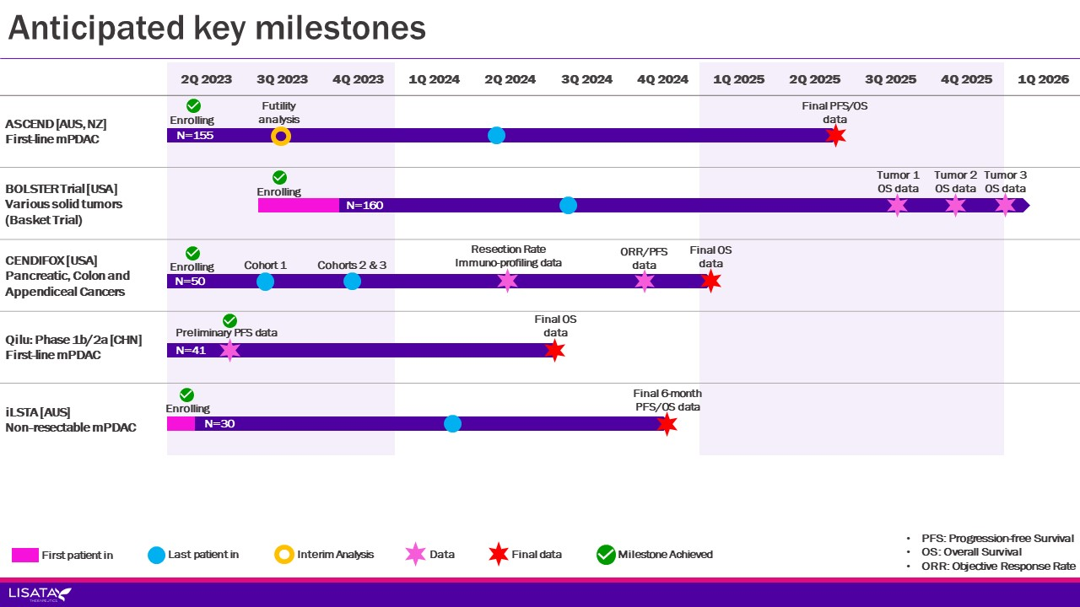

27
Index

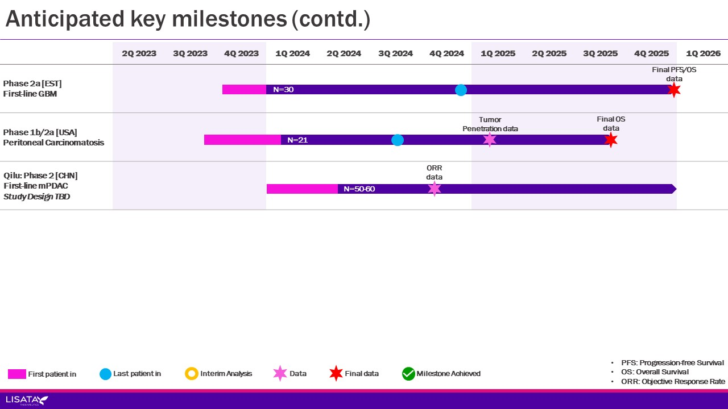

Ischemic Repair (CD34+ Cell Technology)
The CD34+ cell was discovered as a result of the deliberate search for a cell capable of stimulating the development and/or repair of blood vessels. All tissues in the body maintain their function by replacing cells over time. In addition to the maintenance function, the body must also be capable of building new blood vessels after injury. A CD34+ cell is an endothelial progenitor cell that has the ability to stimulate new blood vessel formation at the level of the microvasculature. No other native cell discovered to date has demonstrated this same capability.
Our proprietary cell technology using autologous (a patient’s own naturally occurring) CD34+ cells has led to the development of therapeutic product candidates designed to address diseases and conditions caused by ischemia. Ischemia occurs when the supply of oxygenated blood to healthy tissue is restricted or reduced. Through the administration of CD34+ cells, we seek to promote the development and formation of new microvasculature and thereby increase blood flow to the impacted area. We believe that a number of conditions caused by underlying ischemic injury can be improved through our CD34+ cell technology, including, but not limited to, Buerger's disease, critical limb ischemia (“CLI”), coronary microvascular dysfunction (“CMD”), refractory angina, and diabetic kidney disease (“DKD”).
HONEDRA® for Treatment of Critical Limb Ischemia
Our randomized, open-label, registration-eligible study of HONEDRA® in Japan for the treatment of CLI and Buerger's disease has, to date, demonstrated positive trends in both safety and efficacy. The HONEDRA® study's enrollment, however, has been significantly curtailed by the COVID-19 pandemic's impact in Japan, including the States of Emergency in Japan that have persisted for much of 2020, 2021, and 2022. Due to the significant and continued operational and financial burden incurred as a result of these COVID-19 delays, coupled with the unpredictability of the timing of site enrollment re-initiation, we suspended further enrollment in the fourth quarter of 2021. Following study suspension, we completed all protocol-defined patient observations and completed the clinical study report. Data from the follow-up of all patients completed in the registration-eligible clinical trial in Japan have been compiled and are the subject of discussions with the Pharmaceuticals and Medical Devices Agency (“PMDA”) in Japan as part of the Japanese regulatory pre-consultation process and in preparation for the formal clinical consultation meetings which precede a Japanese new drug application (“JNDA”). To date, the PMDA has provided advice on how to prepare for the formal consultation meeting and has indicated their preference for additional clinical information to accompany the filing of a JNDA. Concomitantly, the Company has reinforced its efforts to secure a Japanese partner to complete the remaining steps of development/registration as well as eventual commercialization in Japan.
28
Index
Merger with Cend Therapeutics, Inc. and Name Change
On September 15, 2022, the Company, then operating as Caladrius Biosciences, Inc. (“Caladrius”), completed its acquisition of Cend Therapeutics, Inc. (“Cend”), a Delaware corporation (the “Merger”), in accordance with the terms of the Agreement and Plan of Merger and Reorganization (the “Merger Agreement”), dated as of April 26, 2022, by and among Caladrius, Cend and CS Cedar Merger Sub, Inc. (“Merger Sub”).
Pursuant to the terms set forth in the Merger Agreement and effective September 15, 2022 (the “Effective Time”): (i) Merger Sub merged with and into Cend, with Cend surviving as a wholly owned subsidiary of Caladrius, (ii) Caladrius changed its name to Lisata Therapeutics, Inc. in connection with and immediately following to the Effective Time, and (iii) Caladrius effected a 1:15 reverse stock split of its common stock (“Reverse Stock Split”) prior to the Effective Time. At the Effective Time, each share of Cend's common stock outstanding immediately prior to the Effective Time was converted into the right to receive shares of Lisata’s common stock based on an exchange ratio of 0.5338 (the “Exchange Ratio”), after taking into account the Reverse Stock Split. In connection with the Merger close, the Company issued an aggregate of 3,772,768 shares of common stock, based on the Exchange Ratio, to holders of Cend, in exchange for all of the Cend capital stock outstanding immediately prior to the closing of the Merger.
Pursuant to the Merger Agreement, we assumed all of the outstanding and unexercised options to purchase shares of Cend capital stock under the 2016 Equity Incentive Plan (the “Cend Plan”), and, in connection with the Merger, such options were converted into options to purchase shares of Lisata’s common stock based on the Exchange Ratio. At the closing of the Merger at the Effective Time, we assumed Cend's stock options to purchase an aggregate of 1,227,776 shares of the Company's common stock.
Caladrius was considered to be the accounting acquirer based on the terms of the Merger Agreement and certain factors including: (i) Caladrius owned approximately 52% of the Company's outstanding shares of common stock immediately following the close of the Merger; (ii) although both entities contributed to the new management team of Lisata, the Caladrius team has more individuals on the management team and will hold the CEO, CMO and other senior management roles; (iii) Caladrius paid a premium to acquire Cend’s assets; and (iv) Caladrius was significantly larger than Cend regarding total assets, operations, and research and development activities. The Merger was accounted for as an asset acquisition as substantially all of the fair value is concentrated in in-process research and development (“IPR&D”). Cend’s assets (except for cash and working capital) were measured and recognized as an allocation of the transaction price based on their relative fair values as of the transaction date with any value associated with IPR&D with no alternative future use being expensed. The prior reported operating results prior to the Merger close are those of Caladrius.
Additional Out-licensing Opportunities
Our broad intellectual property portfolio of assets includes notable programs available for out-licensing in order to augment or continue their clinical development. Our current long-term strategy focuses on advancing our therapies through development with the ultimate objective of obtaining market authorizations and entering commercialization, either alone or with partners, to provide treatment options to patients suffering from life-threatening medical conditions. We believe that we are well-positioned to realize potentially meaningful value increases within our own proprietary pipeline if we are successful in advancing our product candidates to their next significant development milestones.
Impact of the COVID-19 Pandemic
We continue to closely monitor the impact of the COVID-19 pandemic on all aspects of our business, including how it has and will continue to impact our operations and the operations of our suppliers, vendors and business partners, and may take further precautionary and preemptive actions as may be required by federal, state or local authorities. In addition, we have taken steps to minimize the current environment’s impact on our business and strategy, including devising contingency plans and securing additional resources from third party service providers. Our phase 2b trial of XOWNA® in the United States experienced delays in enrolling patients as a result of COVID-19. In May 2022, we announced that enrollment in the FREEDOM Trial was suspended and that we intended to conduct an interim analysis of the data from not less than the first 20 patients enrolled using the 6-month follow-up data to evaluate the efficacy and safety of XOWNA® in subjects with CMD. Following this analysis along with Key Opinion Leaders’ input, we determined that execution of a redesigned FREEDOM-like trial would be the appropriate next step, but the cost of such a trial would be prohibitively expensive to undergo without a strategic partner. Accordingly, our board of directors concluded that XOWNA® development will only be continued if a strategic partner that can contribute the necessary capital for a redesigned trial is identified and secured. There can be no assurance that we will be able to identify such a partner and enter into an agreement with such partner on acceptable terms or at all.
Beyond its impact on our development pipeline described above, the extent to which COVID-19 ultimately impacts our business, results of operations and financial condition will depend on future developments, which remain highly uncertain and
29
Index
cannot be predicted with confidence, such as the duration of the outbreak, the emergence of new variants, new information that may emerge concerning the severity of COVID-19 or the effectiveness of actions taken to contain COVID-19 or treat its impact, including vaccination campaigns, among others. If we or any of the third parties with whom we engage, however, were to experience any additional shutdowns or other prolonged business disruptions, our ability to conduct our business in the manner and on the timelines presently planned could be materially or negatively affected, which could have a material adverse impact on our business, financial condition and results of operations. It is possible that our clinical development timelines could continue to be negatively affected by COVID-19, which could materially and adversely affect our business, financial condition and results of operations. See “Risk Factors” for additional discussion of the potential adverse impact of the COVID-19 pandemic on our business, financial condition and results of operations.

Results of Operations
Three Months Ended June 30, 2023 Compared to Three Months Ended June 30, 2022
The following table summarizes our results of operations for the three months ended June 30, 2023 and June 30, 2022:
 |  |  | Three Months Ended June 30,
 |  |  | 2023 |  |  |  |  |  | 2022 |  |  |  |  |  | Change
Operating Expenses:
Research and development |  |  | $ | 3,162 |  |  |  |  | $ | 3,234 |  |  |  |  | $ | (72)
General and administrative |  |  | 3,713 |  |  |  |  |  | 3,486 |  |  |  |  |  | 227
Total operating expenses |  |  | 6,875 |  |  |  |  |  | 6,720 |  |  |  |  |  | 155
Loss from operations |  |  | (6,875) |  |  |  |  |  | (6,720) |  |  |  |  |  | (155)
Total other income (expense) |  |  | 518 |  |  |  |  |  | 94 |  |  |  |  |  | 424
Benefit from income taxes |  |  | (2,330) |  |  |  |  |  | — |  |  |  |  |  | 2,330
Net loss |  |  | $ | (4,027) |  |  |  |  | $ | (6,626) |  |  |  |  | $ | 2,599
Overall, net losses were $4.0 million for the three months ended June 30, 2023, compared to $6.6 million for the three months ended June 30, 2022.
For the three months ended June 30, 2023, operating expenses totaled $6.9 million compared to $6.7 million for the three months ended June 30, 2022, representing an increase of 2.3%. Operating expenses comprised the following:
•Research and development expenses were approximately $3.2 million for the three months ended June 30, 2023, compared to $3.2 million for the three months ended June 30, 2022, representing a decrease of $0.1 million or 2.2%. This was primarily due to expenses associated with our study start up activities in the current year associated with the LSTA1 Phase 2 proof-of-concept basket trial in various solid tumors in combination with the corresponding standards of care, enrollment activities for the LSTA1 Phase 2b ASCEND study and chemistry, manufacturing and control (CMC) activities for LSTA1 being offset by expenses associated with our Ischemic Repair programs (XOWNA® Phase 2b study, HONEDRA® and diabetic kidney disease) in the prior year.
•General and administrative expenses were approximately $3.7 million for the three months ended June 30, 2023, compared to $3.5 million for the three months ended June 30, 2022, representing an increase of $0.2 million or 6.5%. This was primarily due to severance costs associated with the elimination of the Chief Business Officer position on May 1, 2023, partially offset by non-recurring merger related costs in the prior year.
Historically, to minimize our use of cash, we have used a variety of equity instruments to compensate employees, consultants and other service providers. The use of these instruments has resulted in charges to the results of operations, which have been significant in the past.
30
Index
Other Income (Expense)
Total other income (expense) is comprised of investment income from cash, cash equivalents and marketable securities for both three months ended June 30, 2023 and 2022 and a loss on sale related to the sale of our New Jersey net operating losses (“NJ NOLs”) in the three months ended June 30, 2023.
Income Tax Benefit
In April 2023, we received final approval from the New Jersey Economic Development Authority (“NJEDA”) under the Technology Business Tax Certificate Transfer Program (“Program”) to sell a percentage of our NJ NOLs, which were subsequently sold to a qualifying and approved buyer pursuant to the Program for net proceeds of $2.2 million. The $2.3 million of NJ NOLs related tax benefits (“NJ NOL Tax Benefits”) have been recorded as a benefit from income taxes and the loss on sale of $0.1 million recorded in other income (expense).
Six Months Ended June 30, 2023 Compared to Six Months Ended June 30, 2022
The following table summarizes our results of operations for the six months ended June 30, 2023 and June 30, 2022:
 |  |  | Six Months Ended June 30,
 |  |  | 2023 |  |  |  |  |  | 2022 |  |  |  |  |  | Change
Operating Expenses:
Research and development |  |  | $ | 6,341 |  |  |  |  | $ | 6,516 |  |  |  |  | $ | (175)
General and administrative |  |  | 7,378 |  |  |  |  |  | 6,824 |  |  |  |  |  | 554
Total operating expenses |  |  | 13,719 |  |  |  |  |  | 13,340 |  |  |  |  |  | 379
Loss from operations |  |  | (13,719) |  |  |  |  |  | (13,340) |  |  |  |  |  | (379)
Total other income (expense) |  |  | 1,175 |  |  |  |  |  | 9 |  |  |  |  |  | 1,166
Benefit from income taxes |  |  | (2,330) |  |  |  |  |  | (2,479) |  |  |  |  |  | (149)
Net loss |  |  | $ | (10,214) |  |  |  |  | $ | (10,852) |  |  |  |  | $ | 638
Overall, net losses were $10.2 million for the six months ended June 30, 2023, compared to $10.9 million for the six months ended June 30, 2022.
For the six months ended June 30, 2023, operating expenses totaled $13.7 million compared to $13.3 million for the six months ended June 30, 2023, representing an increase of 2.8%. Operating expenses comprised the following:
•Research and development expenses were approximately $6.3 million for the six months ended June 30, 2023, compared to $6.5 million for the six months ended June 30, 2022, representing a decrease of $0.2 million or 2.7%. This was primarily due to expenses associated with our study start up activities in the current year associated with the LSTA1 Phase 2 proof-of-concept basket trial in various solid tumors in combination with the corresponding standards of care, enrollment activities for the LSTA1 Phase 2b ASCEND study and chemistry, manufacturing and control (CMC) activities for LSTA1 being offset by expenses associated with our Ischemic Repair programs (XOWNA® Phase 2b study, HONEDRA® and diabetic kidney disease) in the prior year.
•General and administrative expenses were approximately $7.4 million for the six months ended June 30, 2023, compared to $6.8 million for the six months ended June 30, 2022, representing an increase of $0.6 million or 8.1%. This was primarily due to severance costs associated with the elimination of the Chief Business Officer position on May 1, 2023, partially offset by non-recurring merger related costs in the prior year.
Historically, to minimize our use of cash, we have used a variety of equity instruments to compensate employees, consultants and other service providers. The use of these instruments has resulted in charges to the results of operations, which have been significant in the past.
31
Index
Other Income (Expense)
Total other income (expense) is comprised of investment income from cash, cash equivalents and marketable securities for both six months ended June 30, 2023 and 2022 and a loss on sale related to the sale of our NJ NOLs in the six months ended June 30, 2023 and 2022.
Income Tax Benefit
In April 2023, we received final approval from the NJEDA under the Program to sell a percentage of our NJ NOLs, which were subsequently sold to a qualifying and approved buyer pursuant to the Program for net proceeds of $2.2 million. The $2.3 million of our NJ NOL Tax Benefits have been recorded as a benefit from income taxes and the loss on sale of $0.1 million recorded in other income (expense).
In February 2022, we received final approval from the NJEDA under the Program to sell a percentage of our NJ NOLs, which were subsequently sold to a qualifying and approved buyer pursuant to the Program for net proceeds of $2.3 million. The $2.5 million of our NJ NOL Tax Benefits have been recorded as a benefit from income taxes and the loss on sale of $0.1 million recorded in other income (expense).

32
Index
Analysis of Liquidity and Capital Resources
As of June 30, 2023, we had cash, cash equivalents and marketable securities of approximately $57.6 million, working capital of approximately $57.1 million, and stockholders’ equity of approximately $58.0 million.
During the six months ended June 30, 2023, we met our immediate cash requirements through existing cash balances. Additionally, we used equity and equity-linked instruments to pay for services and compensation.
Net cash (used in) or provided by, operating, investing and financing activities were as follows (in thousands):
 |  |  | Six Months Ended June 30,
 |  |  | 2023 |  |  |  |  |  | 2022
Net cash used in operating activities |  |  | $ | (12,380) |  |  |  |  | $ | (10,704)
Net cash provided by investing activities |  |  | 3,564 |  |  |  |  |  | 19,544
Net cash provided by (used in) financing activities |  |  | 367 |  |  |  |  |  | (139)

Operating Activities
Our cash used in operating activities during the six months ended June 30, 2023 was $12.4 million, which is comprised of (i) our net loss of $10.2 million, adjusted for non-cash expenses totaling $0.9 million (which includes adjustments for equity-based compensation, depreciation and amortization, a loss on disposal of fixed assets, and amortization/accretion of marketable securities), and (ii) changes in operating assets and liabilities using approximately $3.1 million.
Our cash used in operating activities during the six months ended June 30, 2022 was $10.7 million, which is comprised of (i) our net loss of $10.9 million, adjusted for non-cash expenses totaling $2.0 million (which includes adjustments for equity-based compensation, depreciation and amortization, and amortization/accretion of marketable securities) and (ii) changes in operating assets and liabilities using approximately $1.9 million.
Investing Activities
Our cash provided by investing activities during the six months ended June 30, 2023 totaled $3.6 million and was primarily due to net sales of marketable securities (net of purchases of marketable securities).
Our cash used in investing activities during the six months ended June 30, 2022 totaled $19.5 million and was primarily due to net sales of marketable securities (net of purchases of marketable securities) partially offset by our investment in Cend.
Financing Activities
Our cash provided by financing activities during the six months ended June 30, 2023 totaled $0.4 million and consisted of proceeds from the issuance of shares through our ATM Agreement of $0.3 million, option exercise proceeds of $0.2 million partially offset by tax withholding-related payments of $0.1 million on net share settlement equity awards to employees.
Our cash used in financing activities during the six months ended June 30, 2022 totaled $0.1 million and consisted primarily of tax withholding-related payments on net share settlement equity awards to employees.
Liquidity and Capital Requirements Outlook
To meet our short and long-term liquidity needs, we expect to use existing cash balances, marketable securities and a variety of other means. Other sources of liquidity could include additional potential issuances of debt or equity securities in public or private financings, partnerships and/or collaborations and/or sale of assets. Our history of operating losses and liquidity challenges may make it difficult for us to raise capital on acceptable terms or at all. The demand for the equity and debt of pharmaceutical companies like ours is dependent upon many factors, including the general state of the financial markets. During times of extreme market volatility, capital may not be available on favorable terms, if at all. Our inability to obtain such additional capital could materially and adversely affect our business operations. We will also continue to seek, as appropriate, grants for scientific and clinical studies from various governmental agencies and foundations, and other sources of non-dilutive funding. We believe that our cash on hand and marketable securities will enable us to fund operating expenses for at least the next 12 months following the issuance of our financial statements. Our future capital requirements are difficult to forecast and will depend on many factors including the timing and nature of any other strategic transactions that we undertake; and our ability to establish and maintain collaboration partnerships, in-license/out-license or other similar arrangements and the financial terms of such agreements.
33
Index
On June 4, 2021, we entered into an At The Market Offering Agreement (the “ATM Agreement”) with H.C. Wainwright & Co., LLC as sales agent, in connection with an “at the market offering” under which we from time to time may offer and sell shares of our common stock having an aggregate offering price of up to $50.0 million. Subsequent to the filing of our Form 10-K on March 22, 2022, the aggregate market value of our outstanding common stock held by non-affiliates was approximately $43.6 million. Pursuant to General Instruction I.B.6 of Form S-3, since the aggregate market value of our outstanding common stock held by non-affiliates was below $75.0 million at the time of such Form 10-K filing, the aggregate amount of securities that we are permitted to offer and sell was reduced to $17,698,943, which was equal to one-third of the aggregate market value of our common stock held by non-affiliates as of September 21, 2022. Since inception we have issued 64,394 shares of common stock under the ATM Agreement for net proceeds of $270,774.
While we continue to seek capital through a number of means, there can be no assurance that additional financing will be available on acceptable terms, if at all, and our negotiating position in capital generating efforts may worsen as existing resources are used. Additional equity financing may be dilutive to our stockholders; debt financing, if available, may involve significant cash payment obligations and covenants that restrict our ability to operate as a business; our stock price may not reach levels necessary to induce option or warrant exercises; and asset sales may not be possible on terms we consider acceptable. If we are unable to access capital necessary to meet our long-term liquidity needs, we may have to delay the expansion of our business or raise funds on terms that we currently consider unfavorable.

Off-Balance Sheet Arrangements
We do not have any off-balance sheet arrangements.
Critical Accounting Policies and Estimates
There have been no material changes in our critical accounting policies and estimates during the three and six months ended June 30, 2023, compared to those reported in our 2022 Form 10-K.

ITEM 3. QUANTITATIVE AND QUALITATIVE DISCLOSURES ABOUT MARKET RISK
Not applicable.

ITEM 4. CONTROLS AND PROCEDURES
(a) Disclosure Controls and Procedures
Disclosure controls and procedures are our controls and other procedures that are designed to ensure that information required to be disclosed in the reports that we file or submit under the Securities Exchange Act of 1934 (as defined in Rules 13a-15(e) and 15d-15(e) under the Securities Exchange Act of 1934), as amended (the “Exchange Act”) is recorded, processed, summarized and reported within the time periods specified in the SEC’s rules and forms. Disclosure controls and procedures include, without limitation, controls and procedures designed to ensure that information required to be disclosed in the reports that we file under the Exchange Act is accumulated and communicated to management, including our Chief Executive Officer, who serves as our principal executive officer and our principal financial officer, as appropriate, to allow timely decisions regarding required disclosure. In designing and evaluating the disclosure controls and procedures, management recognizes that any controls and procedures, no matter how well-designed and operated, can provide only reasonable assurance of achieving the desired control objectives. Due to the inherent limitations of control systems, not all misstatements may be detected. These inherent limitations include the realities that judgments in decision-making can be faulty and that breakdowns can occur because of a simple error or mistake. Additionally, controls can be circumvented by the individual acts of some persons, by collusion of two or more people, or by management override of the control. Controls and procedures can only provide reasonable, not absolute, assurance that the above objectives have been met.
As of June 30, 2023, we evaluated, with the participation of our management, including our Chief Executive Officer, the effectiveness of our disclosure controls and procedures as defined in Rules 13a-15(e) and 15d-15(e) under the Exchange Act. Based on that evaluation, our Chief Executive Officer concluded that our disclosure controls and procedures were effective, at the reasonable assurance level, in ensuring that information required to be disclosed by us in the reports that we file or submit under the Exchange Act is recorded, processed, summarized and reported, within the time periods specified in the SEC’s rules and forms and is accumulated and communicated to management, including the Chief Executive Officer, as appropriate to allow timely decisions regarding required disclosure.
34
Index
(b) Changes in Internal Control over Financial Reporting
There were no changes in our internal control over financial reporting, as such term is defined in Exchange Act Rule 13a-15, that occurred during our last quarter to which this Quarterly Report relates that have materially affected, or are reasonably likely to materially affect, our internal control over financial reporting.

35
Index
PART II

OTHER INFORMATION

ITEM 1. LEGAL PROCEEDINGS
Other than as disclosed in “Note 14 – Contingencies” set forth in the Notes to Unaudited Consolidated Financial Statements, which are included herein, there are no material changes to the disclosures previously reported in our 2022 Form 10-K.

ITEM 1A. RISK FACTORS
There have been no material changes to the risk factors previously reported in our 2022 Form 10-K. See the risk factors set forth in our 2022 Annual Report on Form 10-K under the caption “Item 1A - Risk Factors.”

ITEM 2. UNREGISTERED SALES OF EQUITY SECURITIES AND USE OF PROCEEDS
None.

ITEM 3. DEFAULTS UPON SENIOR SECURITIES
None.

ITEM 4. MINE SAFETY DISCLOSURES
Not applicable.

ITEM 5. OTHER INFORMATION
None.

ITEM 6. EXHIBITS
The Exhibit Index appearing immediately after the signature page to this Form 10-Q is incorporated herein by reference.

36
Index
SIGNATURES

Pursuant to the requirements of the Securities Exchange Act of 1934, the registrant has duly caused this report to be signed on its behalf by the undersigned thereunto duly authorized.
 |  |  |  |  |  | LISATA THERAPEUTICS, INC.
August 14, 2023 |  |  |  |  |  | By: /s/ David J. Mazzo, PhD  Name: David J. Mazzo, PhD  Title: President & Chief Executive Officer  (Principal Executive Officer, Principal Financial Officer  and Principal Accounting Officer)

37
Index
LISATA THERAPEUTICS, INC.
FORM 10-Q

Exhibit Index
10.1 |  |  | + |  |  | Severance Agreement, dated May 1, 2023, by and between the Company and David Slack.
31.1 |  |  | * |  |  | Certification of Principal Executive Officer, Principal Financial Officer and Principal Accounting Officer pursuant to Section 302 of the Sarbanes-Oxley Act of 2002
32 |  |  | ** |  |  | Certification of Principal Executive Officer, Principal Financial Officer and Principal Accounting Officer pursuant to 18 U.S.C. Section 1350, as adopted pursuant to Section 906 of the Sarbanes-Oxley Act of 2002
101.INS |  |  |  |  |  | Inline XBRL Instance Document - the instance document does not appear in the Interactive Data File because its XBRL tags are embedded within the Inline XBRL document
101.SCH |  |  |  |  |  | Inline XBRL Taxonomy Extension Schema
101.CAL |  |  |  |  |  | Inline XBRL Taxonomy Extension Calculation Linkbase
101.DEF |  |  |  |  |  | Inline XBRL Taxonomy Extension Definition Linkbase
101.LAB |  |  |  |  |  | Inline XBRL Taxonomy Extension Label Linkbase
101.PRE |  |  |  |  |  | Inline XBRL Taxonomy Extension Presentation Linkbase
104 |  |  |  |  |  | Cover Page Interactive Data File (formatted as inline XBRL and contained in Exhibit 101)
_______________
+ |  |  | Management contract or compensatory plan, contract or arrangement.
* |  |  | Filed herewith.
** |  |  | Furnished herewith.
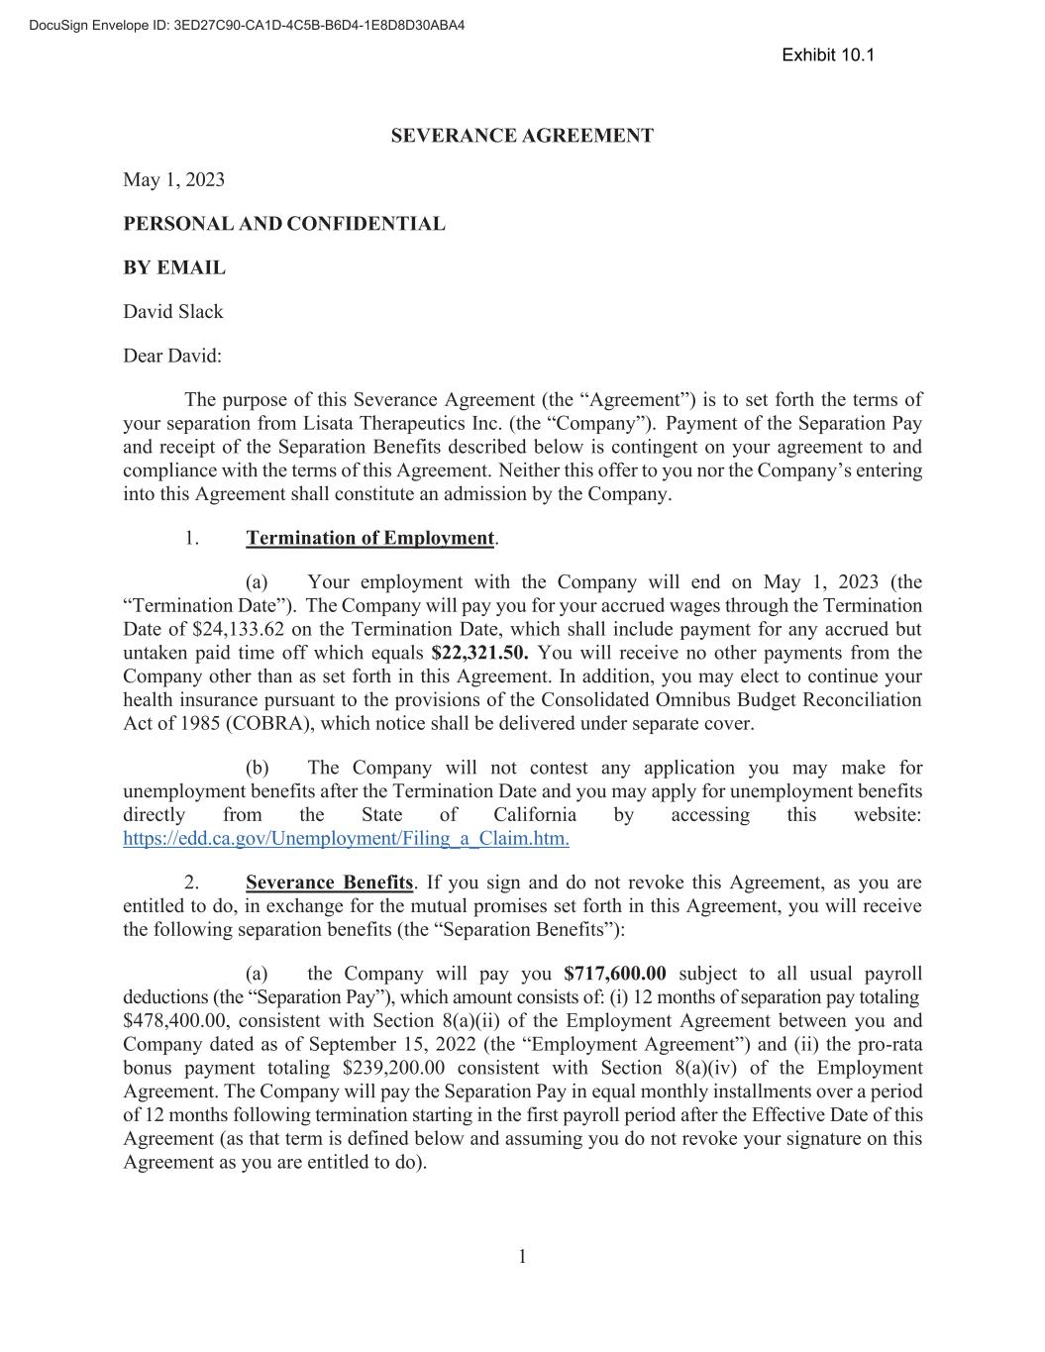
38
1 SEVERANCE AGREEMENT May 1, 2023 PERSONAL AND CONFIDENTIAL BY EMAIL David Slack Dear David: The purpose of this Severance Agreement (the “Agreement”) is to set forth the terms of your separation from Lisata Therapeutics Inc. (the “Company”). Payment of the Separation Pay and receipt of the Separation Benefits described below is contingent on your agreement to and compliance with the terms of this Agreement. Neither this offer to you nor the Company’s entering into this Agreement shall constitute an admission by the Company. 1. Termination of Employment. (a) Your employment with the Company will end on May 1, 2023 (the “Termination Date”). The Company will pay you for your accrued wages through the Termination Date of $24,133.62 on the Termination Date, which shall include payment for any accrued but untaken paid time off which equals $22,321.50. You will receive no other payments from the Company other than as set forth in this Agreement. In addition, you may elect to continue your health insurance pursuant to the provisions of the Consolidated Omnibus Budget Reconciliation Act of 1985 (COBRA), which notice shall be delivered under separate cover. (b) The Company will not contest any application you may make for unemployment benefits after the Termination Date and you may apply for unemployment benefits directly from the State of California by accessing this website: https://edd.ca.gov/Unemployment/Filing_a_Claim.htm. 2. Severance Benefits. If you sign and do not revoke this Agreement, as you are entitled to do, in exchange for the mutual promises set forth in this Agreement, you will receive the following separation benefits (the “Separation Benefits”): (a) the Company will pay you $717,600.00 subject to all usual payroll deductions (the “Separation Pay”), which amount consists of: (i) 12 months of separation pay totaling $478,400.00, consistent with Section 8(a)(ii) of the Employment Agreement between you and Company dated as of September 15, 2022 (the “Employment Agreement”) and (ii) the pro-rata bonus payment totaling $239,200.00 consistent with Section 8(a)(iv) of the Employment Agreement. The Company will pay the Separation Pay in equal monthly installments over a period of 12 months following termination starting in the first payroll period after the Effective Date of this Agreement (as that term is defined below and assuming you do not revoke your signature on this Agreement as you are entitled to do). Exhibit 10.1

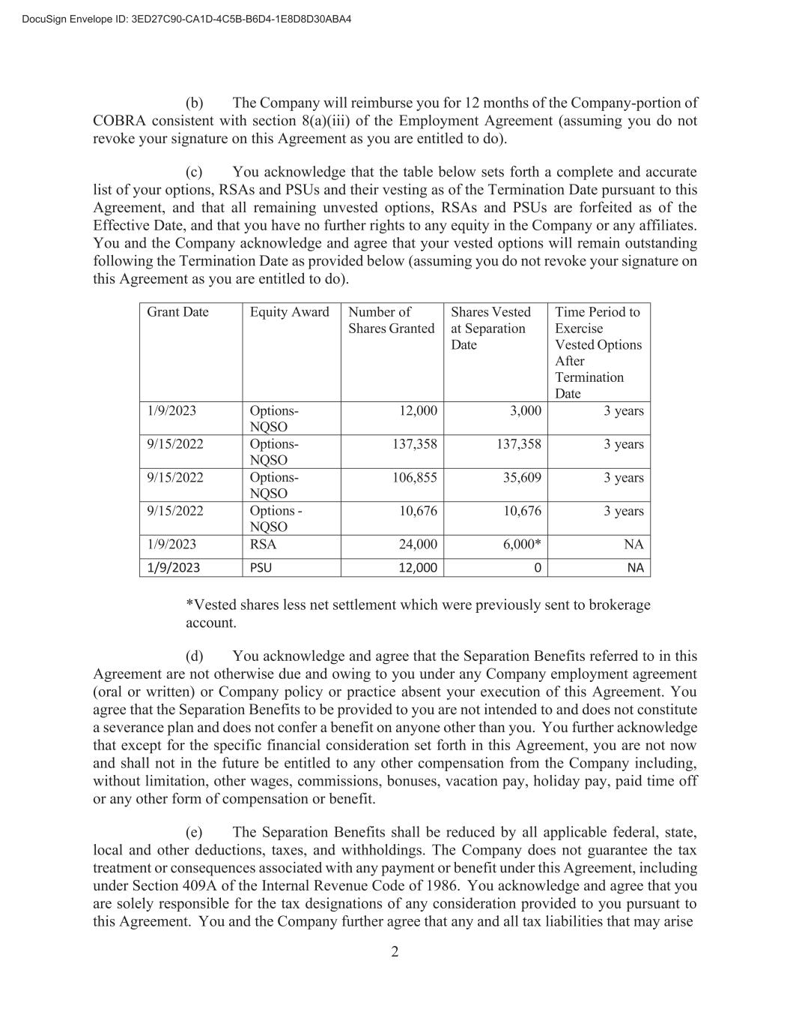
2 (b) The Company will reimburse you for 12 months of the Company-portion of COBRA consistent with section 8(a)(iii) of the Employment Agreement (assuming you do not revoke your signature on this Agreement as you are entitled to do). (c) You acknowledge that the table below sets forth a complete and accurate list of your options, RSAs and PSUs and their vesting as of the Termination Date pursuant to this Agreement, and that all remaining unvested options, RSAs and PSUs are forfeited as of the Effective Date, and that you have no further rights to any equity in the Company or any affiliates. You and the Company acknowledge and agree that your vested options will remain outstanding following the Termination Date as provided below (assuming you do not revoke your signature on this Agreement as you are entitled to do). Grant Date Equity Award Number of Shares Granted Shares Vested at Separation Date Time Period to Exercise Vested Options After Termination Date 1/9/2023 Options- NQSO 12,000 3,000 3 years 9/15/2022 Options- NQSO 137,358 137,358 3 years 9/15/2022 Options- NQSO 106,855 35,609 3 years 9/15/2022 Options - NQSO 10,676 10,676 3 years 1/9/2023 RSA 24,000 6,000* NA 1/9/2023 PSU 12,000 0 NA *Vested shares less net settlement which were previously sent to brokerage account. (d) You acknowledge and agree that the Separation Benefits referred to in this Agreement are not otherwise due and owing to you under any Company employment agreement (oral or written) or Company policy or practice absent your execution of this Agreement. You agree that the Separation Benefits to be provided to you are not intended to and does not constitute a severance plan and does not confer a benefit on anyone other than you. You further acknowledge that except for the specific financial consideration set forth in this Agreement, you are not now and shall not in the future be entitled to any other compensation from the Company including, without limitation, other wages, commissions, bonuses, vacation pay, holiday pay, paid time off or any other form of compensation or benefit. (e) The Separation Benefits shall be reduced by all applicable federal, state, local and other deductions, taxes, and withholdings. The Company does not guarantee the tax treatment or consequences associated with any payment or benefit under this Agreement, including under Section 409A of the Internal Revenue Code of 1986. You acknowledge and agree that you are solely responsible for the tax designations of any consideration provided to you pursuant to this Agreement. You and the Company further agree that any and all tax liabilities that may arise

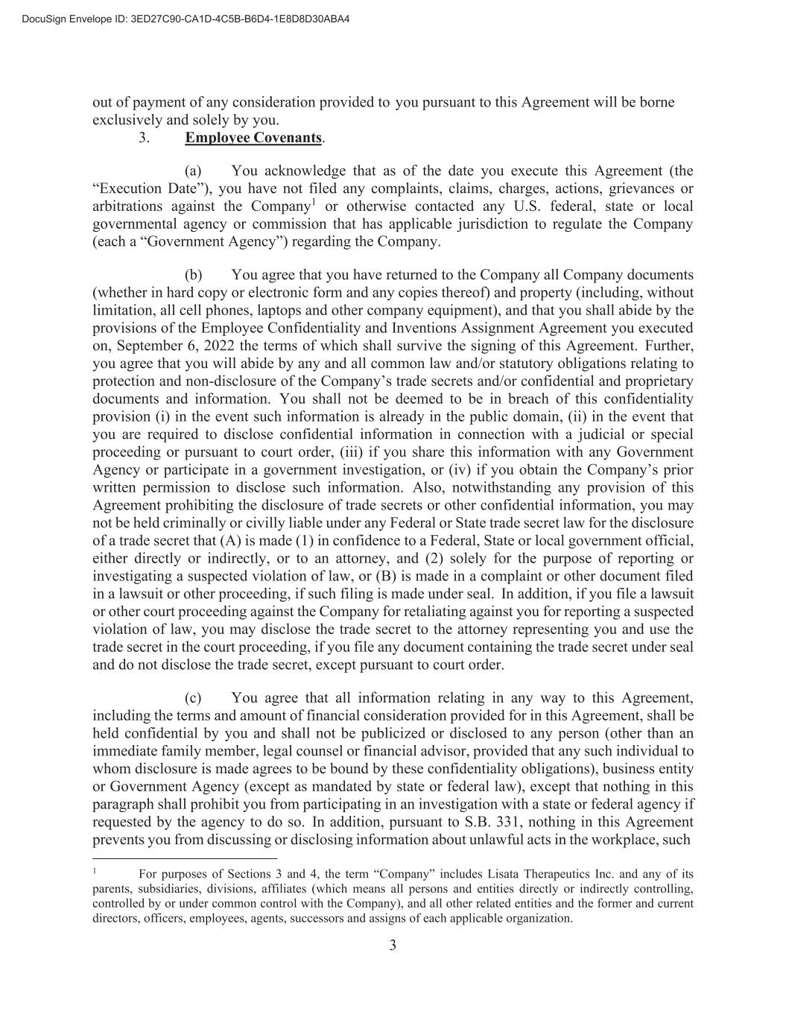
3 out of payment of any consideration provided to you pursuant to this Agreement will be borne exclusively and solely by you. 3. Employee Covenants. (a) You acknowledge that as of the date you execute this Agreement (the “Execution Date”), you have not filed any complaints, claims, charges, actions, grievances or arbitrations against the Company1 or otherwise contacted any U.S. federal, state or local governmental agency or commission that has applicable jurisdiction to regulate the Company (each a “Government Agency”) regarding the Company. (b) You agree that you have returned to the Company all Company documents (whether in hard copy or electronic form and any copies thereof) and property (including, without limitation, all cell phones, laptops and other company equipment), and that you shall abide by the provisions of the Employee Confidentiality and Inventions Assignment Agreement you executed on, September 6, 2022 the terms of which shall survive the signing of this Agreement. Further, you agree that you will abide by any and all common law and/or statutory obligations relating to protection and non-disclosure of the Company’s trade secrets and/or confidential and proprietary documents and information. You shall not be deemed to be in breach of this confidentiality provision (i) in the event such information is already in the public domain, (ii) in the event that you are required to disclose confidential information in connection with a judicial or special proceeding or pursuant to court order, (iii) if you share this information with any Government Agency or participate in a government investigation, or (iv) if you obtain the Company’s prior written permission to disclose such information. Also, notwithstanding any provision of this Agreement prohibiting the disclosure of trade secrets or other confidential information, you may not be held criminally or civilly liable under any Federal or State trade secret law for the disclosure of a trade secret that (A) is made (1) in confidence to a Federal, State or local government official, either directly or indirectly, or to an attorney, and (2) solely for the purpose of reporting or investigating a suspected violation of law, or (B) is made in a complaint or other document filed in a lawsuit or other proceeding, if such filing is made under seal. In addition, if you file a lawsuit or other court proceeding against the Company for retaliating against you for reporting a suspected violation of law, you may disclose the trade secret to the attorney representing you and use the trade secret in the court proceeding, if you file any document containing the trade secret under seal and do not disclose the trade secret, except pursuant to court order. (c) You agree that all information relating in any way to this Agreement, including the terms and amount of financial consideration provided for in this Agreement, shall be held confidential by you and shall not be publicized or disclosed to any person (other than an immediate family member, legal counsel or financial advisor, provided that any such individual to whom disclosure is made agrees to be bound by these confidentiality obligations), business entity or Government Agency (except as mandated by state or federal law), except that nothing in this paragraph shall prohibit you from participating in an investigation with a state or federal agency if requested by the agency to do so. In addition, pursuant to S.B. 331, nothing in this Agreement prevents you from discussing or disclosing information about unlawful acts in the workplace, such 1 For purposes of Sections 3 and 4, the term “Company” includes Lisata Therapeutics Inc. and any of its parents, subsidiaries, divisions, affiliates (which means all persons and entities directly or indirectly controlling, controlled by or under common control with the Company), and all other related entities and the former and current directors, officers, employees, agents, successors and assigns of each applicable organization.

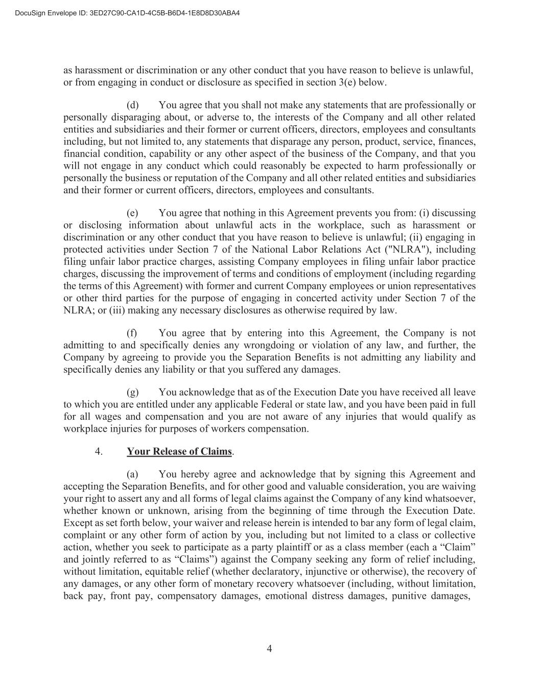
4 as harassment or discrimination or any other conduct that you have reason to believe is unlawful, or from engaging in conduct or disclosure as specified in section 3(e) below. (d) You agree that you shall not make any statements that are professionally or personally disparaging about, or adverse to, the interests of the Company and all other related entities and subsidiaries and their former or current officers, directors, employees and consultants including, but not limited to, any statements that disparage any person, product, service, finances, financial condition, capability or any other aspect of the business of the Company, and that you will not engage in any conduct which could reasonably be expected to harm professionally or personally the business or reputation of the Company and all other related entities and subsidiaries and their former or current officers, directors, employees and consultants. (e) You agree that nothing in this Agreement prevents you from: (i) discussing or disclosing information about unlawful acts in the workplace, such as harassment or discrimination or any other conduct that you have reason to believe is unlawful; (ii) engaging in protected activities under Section 7 of the National Labor Relations Act ("NLRA"), including filing unfair labor practice charges, assisting Company employees in filing unfair labor practice charges, discussing the improvement of terms and conditions of employment (including regarding the terms of this Agreement) with former and current Company employees or union representatives or other third parties for the purpose of engaging in concerted activity under Section 7 of the NLRA; or (iii) making any necessary disclosures as otherwise required by law. (f) You agree that by entering into this Agreement, the Company is not admitting to and specifically denies any wrongdoing or violation of any law, and further, the Company by agreeing to provide you the Separation Benefits is not admitting any liability and specifically denies any liability or that you suffered any damages. (g) You acknowledge that as of the Execution Date you have received all leave to which you are entitled under any applicable Federal or state law, and you have been paid in full for all wages and compensation and you are not aware of any injuries that would qualify as workplace injuries for purposes of workers compensation. 4. Your Release of Claims. (a) You hereby agree and acknowledge that by signing this Agreement and accepting the Separation Benefits, and for other good and valuable consideration, you are waiving your right to assert any and all forms of legal claims against the Company of any kind whatsoever, whether known or unknown, arising from the beginning of time through the Execution Date. Except as set forth below, your waiver and release herein is intended to bar any form of legal claim, complaint or any other form of action by you, including but not limited to a class or collective action, whether you seek to participate as a party plaintiff or as a class member (each a “Claim” and jointly referred to as “Claims”) against the Company seeking any form of relief including, without limitation, equitable relief (whether declaratory, injunctive or otherwise), the recovery of any damages, or any other form of monetary recovery whatsoever (including, without limitation, back pay, front pay, compensatory damages, emotional distress damages, punitive damages,

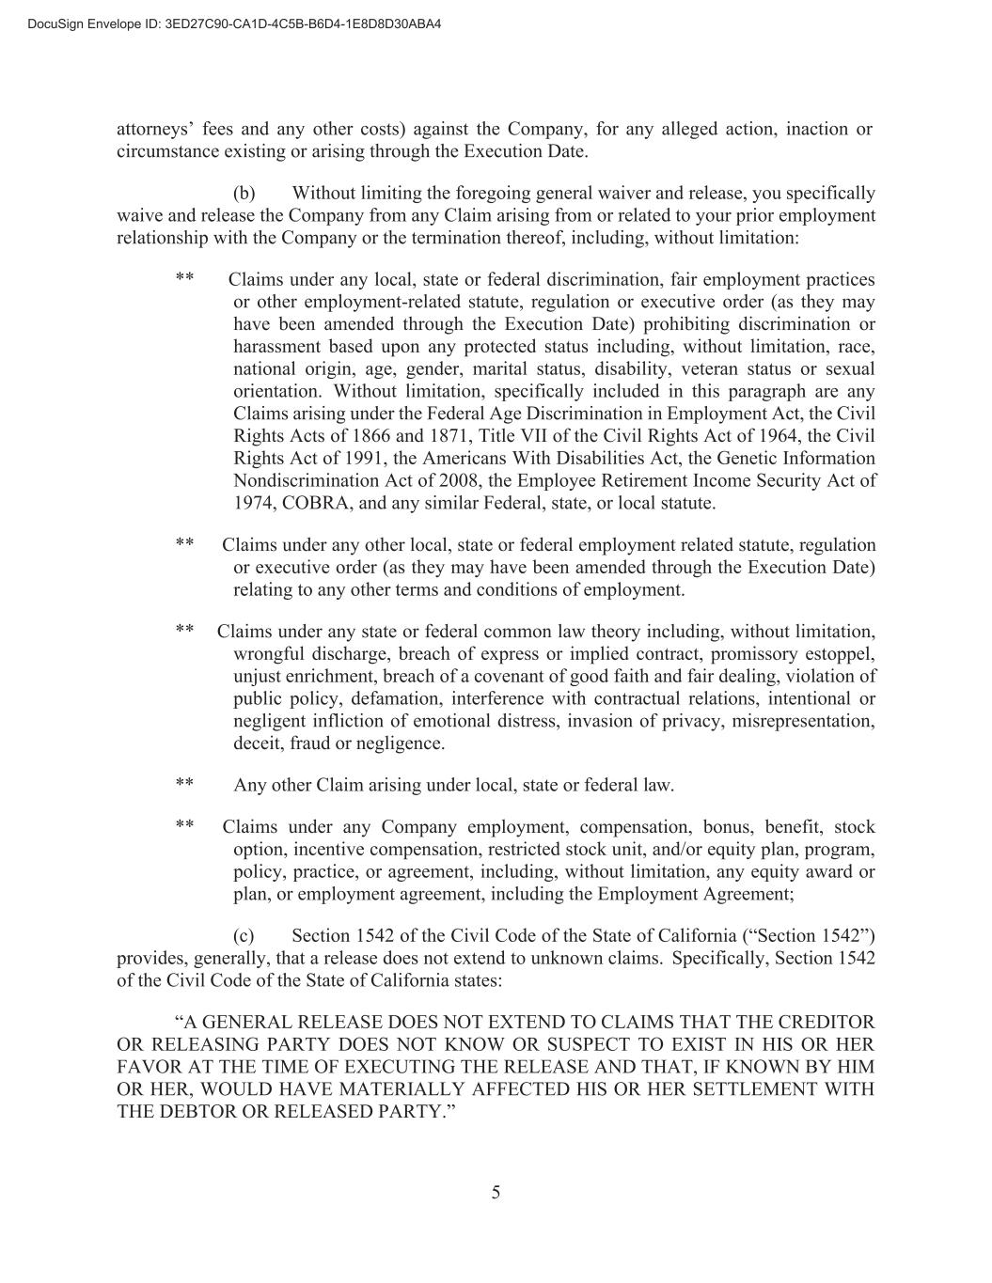
5 attorneys’ fees and any other costs) against the Company, for any alleged action, inaction or circumstance existing or arising through the Execution Date. (b) Without limiting the foregoing general waiver and release, you specifically waive and release the Company from any Claim arising from or related to your prior employment relationship with the Company or the termination thereof, including, without limitation: ** Claims under any local, state or federal discrimination, fair employment practices or other employment-related statute, regulation or executive order (as they may have been amended through the Execution Date) prohibiting discrimination or harassment based upon any protected status including, without limitation, race, national origin, age, gender, marital status, disability, veteran status or sexual orientation. Without limitation, specifically included in this paragraph are any Claims arising under the Federal Age Discrimination in Employment Act, the Civil Rights Acts of 1866 and 1871, Title VII of the Civil Rights Act of 1964, the Civil Rights Act of 1991, the Americans With Disabilities Act, the Genetic Information Nondiscrimination Act of 2008, the Employee Retirement Income Security Act of 1974, COBRA, and any similar Federal, state, or local statute. ** Claims under any other local, state or federal employment related statute, regulation or executive order (as they may have been amended through the Execution Date) relating to any other terms and conditions of employment. ** Claims under any state or federal common law theory including, without limitation, wrongful discharge, breach of express or implied contract, promissory estoppel, unjust enrichment, breach of a covenant of good faith and fair dealing, violation of public policy, defamation, interference with contractual relations, intentional or negligent infliction of emotional distress, invasion of privacy, misrepresentation, deceit, fraud or negligence. ** Any other Claim arising under local, state or federal law. ** Claims under any Company employment, compensation, bonus, benefit, stock option, incentive compensation, restricted stock unit, and/or equity plan, program, policy, practice, or agreement, including, without limitation, any equity award or plan, or employment agreement, including the Employment Agreement; (c) Section 1542 of the Civil Code of the State of California (“Section 1542”) provides, generally, that a release does not extend to unknown claims. Specifically, Section 1542 of the Civil Code of the State of California states: “A GENERAL RELEASE DOES NOT EXTEND TO CLAIMS THAT THE CREDITOR OR RELEASING PARTY DOES NOT KNOW OR SUSPECT TO EXIST IN HIS OR HER FAVOR AT THE TIME OF EXECUTING THE RELEASE AND THAT, IF KNOWN BY HIM OR HER, WOULD HAVE MATERIALLY AFFECTED HIS OR HER SETTLEMENT WITH THE DEBTOR OR RELEASED PARTY.”

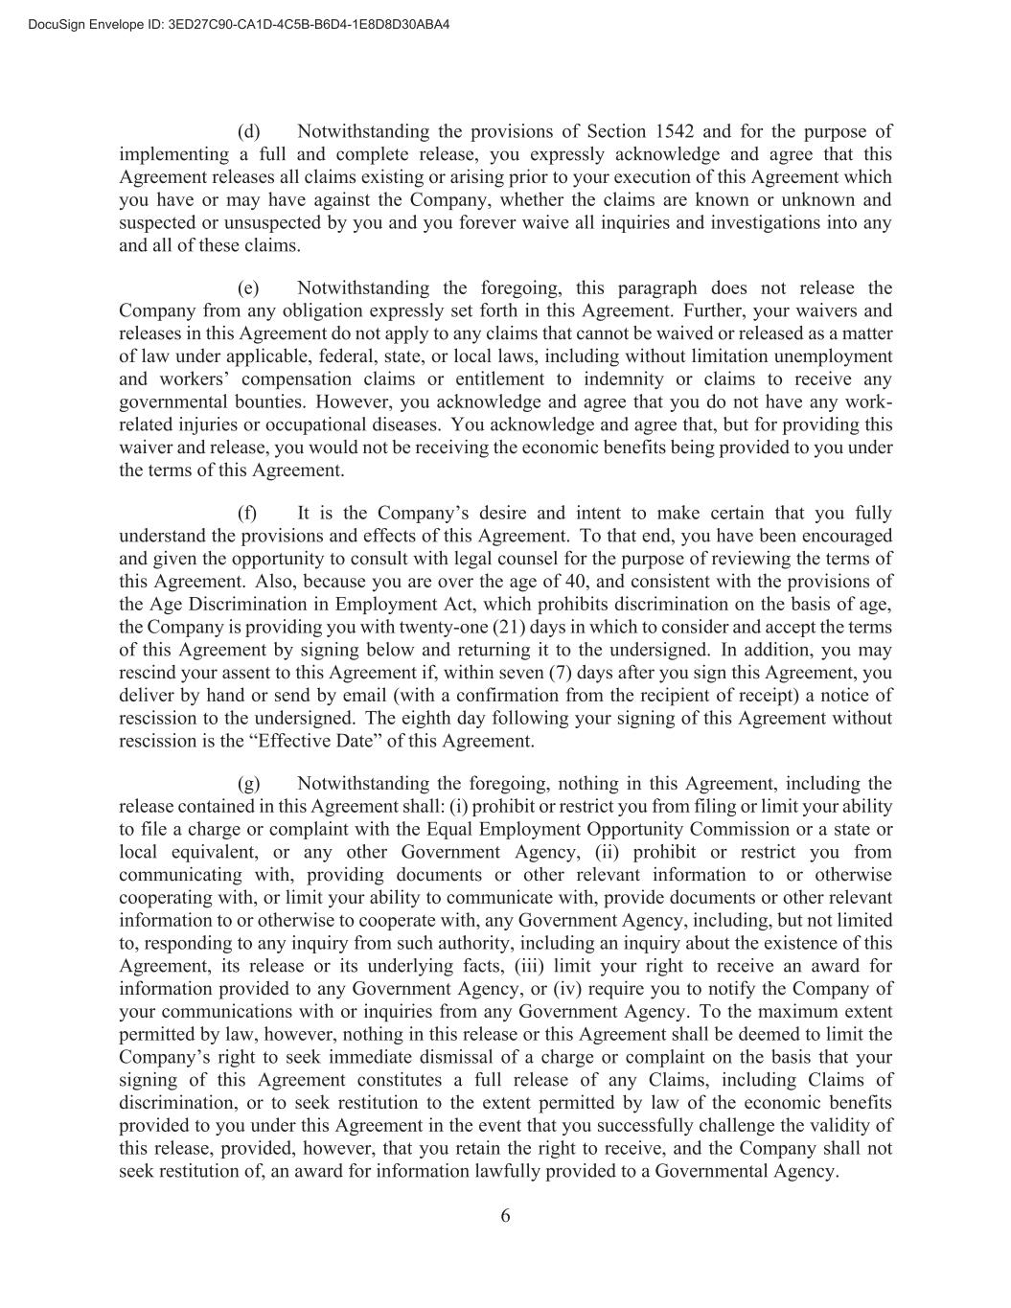
6 (d) Notwithstanding the provisions of Section 1542 and for the purpose of implementing a full and complete release, you expressly acknowledge and agree that this Agreement releases all claims existing or arising prior to your execution of this Agreement which you have or may have against the Company, whether the claims are known or unknown and suspected or unsuspected by you and you forever waive all inquiries and investigations into any and all of these claims. (e) Notwithstanding the foregoing, this paragraph does not release the Company from any obligation expressly set forth in this Agreement. Further, your waivers and releases in this Agreement do not apply to any claims that cannot be waived or released as a matter of law under applicable, federal, state, or local laws, including without limitation unemployment and workers’ compensation claims or entitlement to indemnity or claims to receive any governmental bounties. However, you acknowledge and agree that you do not have any work- related injuries or occupational diseases. You acknowledge and agree that, but for providing this waiver and release, you would not be receiving the economic benefits being provided to you under the terms of this Agreement. (f) It is the Company’s desire and intent to make certain that you fully understand the provisions and effects of this Agreement. To that end, you have been encouraged and given the opportunity to consult with legal counsel for the purpose of reviewing the terms of this Agreement. Also, because you are over the age of 40, and consistent with the provisions of the Age Discrimination in Employment Act, which prohibits discrimination on the basis of age, the Company is providing you with twenty-one (21) days in which to consider and accept the terms of this Agreement by signing below and returning it to the undersigned. In addition, you may rescind your assent to this Agreement if, within seven (7) days after you sign this Agreement, you deliver by hand or send by email (with a confirmation from the recipient of receipt) a notice of rescission to the undersigned. The eighth day following your signing of this Agreement without rescission is the “Effective Date” of this Agreement. (g) Notwithstanding the foregoing, nothing in this Agreement, including the release contained in this Agreement shall: (i) prohibit or restrict you from filing or limit your ability to file a charge or complaint with the Equal Employment Opportunity Commission or a state or local equivalent, or any other Government Agency, (ii) prohibit or restrict you from communicating with, providing documents or other relevant information to or otherwise cooperating with, or limit your ability to communicate with, provide documents or other relevant information to or otherwise to cooperate with, any Government Agency, including, but not limited to, responding to any inquiry from such authority, including an inquiry about the existence of this Agreement, its release or its underlying facts, (iii) limit your right to receive an award for information provided to any Government Agency, or (iv) require you to notify the Company of your communications with or inquiries from any Government Agency. To the maximum extent permitted by law, however, nothing in this release or this Agreement shall be deemed to limit the Company’s right to seek immediate dismissal of a charge or complaint on the basis that your signing of this Agreement constitutes a full release of any Claims, including Claims of discrimination, or to seek restitution to the extent permitted by law of the economic benefits provided to you under this Agreement in the event that you successfully challenge the validity of this release, provided, however, that you retain the right to receive, and the Company shall not seek restitution of, an award for information lawfully provided to a Governmental Agency.

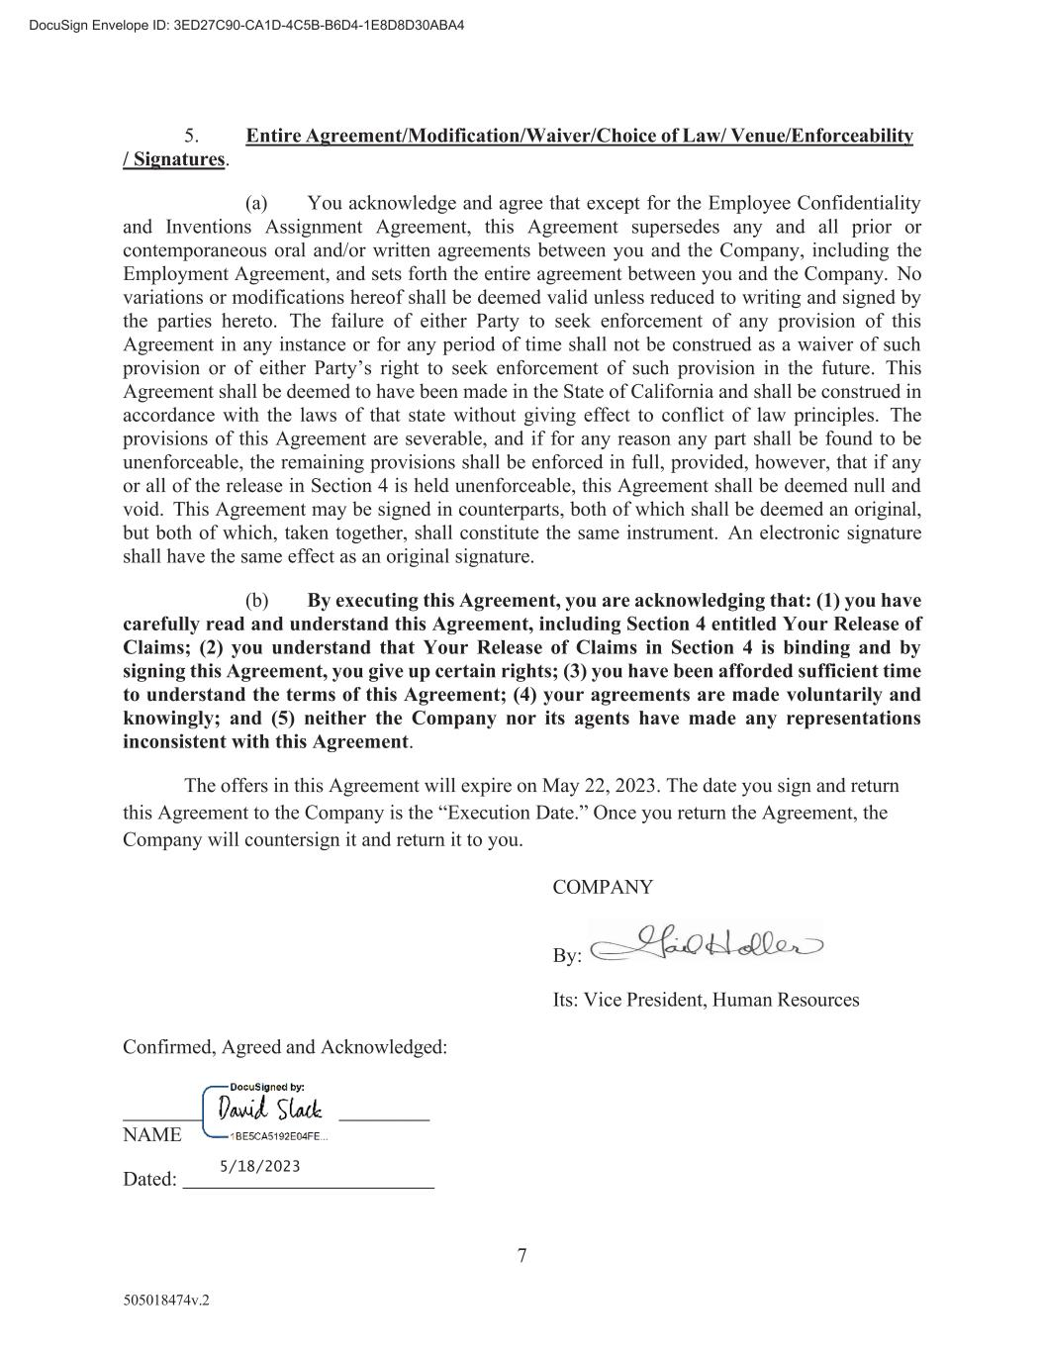
7 505018474v.2 5. Entire Agreement/Modification/Waiver/Choice of Law/ Venue/Enforceability / Signatures. (a) You acknowledge and agree that except for the Employee Confidentiality and Inventions Assignment Agreement, this Agreement supersedes any and all prior or contemporaneous oral and/or written agreements between you and the Company, including the Employment Agreement, and sets forth the entire agreement between you and the Company. No variations or modifications hereof shall be deemed valid unless reduced to writing and signed by the parties hereto. The failure of either Party to seek enforcement of any provision of this Agreement in any instance or for any period of time shall not be construed as a waiver of such provision or of either Party’s right to seek enforcement of such provision in the future. This Agreement shall be deemed to have been made in the State of California and shall be construed in accordance with the laws of that state without giving effect to conflict of law principles. The provisions of this Agreement are severable, and if for any reason any part shall be found to be unenforceable, the remaining provisions shall be enforced in full, provided, however, that if any or all of the release in Section 4 is held unenforceable, this Agreement shall be deemed null and void. This Agreement may be signed in counterparts, both of which shall be deemed an original, but both of which, taken together, shall constitute the same instrument. An electronic signature shall have the same effect as an original signature. (b) By executing this Agreement, you are acknowledging that: (1) you have carefully read and understand this Agreement, including Section 4 entitled Your Release of Claims; (2) you understand that Your Release of Claims in Section 4 is binding and by signing this Agreement, you give up certain rights; (3) you have been afforded sufficient time to understand the terms of this Agreement; (4) your agreements are made voluntarily and knowingly; and (5) neither the Company nor its agents have made any representations inconsistent with this Agreement. The offers in this Agreement will expire on May 22, 2023. The date you sign and return this Agreement to the Company is the “Execution Date.” Once you return the Agreement, the Company will countersign it and return it to you. COMPANY By: Its: Vice President, Human Resources Confirmed, Agreed and Acknowledged: NAME Dated:

Exhibit 31.1

CERTIFICATIONS UNDER SECTION 302

I, David J. Mazzo, PhD, certify that:

1. I have reviewed this Quarterly Report on Form 10-Q of Lisata Therapeutics, Inc.;

2. Based on my knowledge, this report does not contain any untrue statement of a material fact or omit to state a material fact necessary to make the statements made, in light of the circumstances under which such statements were made, not misleading with respect to the period covered by this report;

3. Based on my knowledge, the financial statements, and other financial information included in this report, fairly present in all material respects the financial condition, results of operations and cash flows of the registrant as of, and for, the periods presented in this report;

4. I am responsible for establishing and maintaining disclosure controls and procedures (as defined in Exchange Act Rules 13a-15(e) and 15d-15(e)) and internal control over financial reporting (as defined in Exchange Act Rules 13a-15(f) and 15d-15(f)) for the registrant and have:

a) Designed such disclosure controls and procedures, or caused such disclosure controls and procedures to be designed under my supervision, to ensure that material information relating to the registrant, including its consolidated subsidiaries, is made known to me by others within those entities, particularly during the period in which this report is being prepared;

b) Designed such internal control over financial reporting, or caused such internal control over financial reporting to be designed under my supervision, to provide reasonable assurance regarding the reliability of financial reporting and the preparation of financial statements for external purposes in accordance with generally accepted accounting principles;

c) Evaluated the effectiveness of the registrant's disclosure controls and procedures and presented in this report my conclusions about the effectiveness of the disclosure controls and procedures, as of the end of the period covered by this report based on such evaluation; and

d) Disclosed in this report any change in the registrant’s internal control over financial reporting that occurred during the registrant’s most recent fiscal quarter (the registrant’s fourth fiscal quarter in the case of an annual report) that has materially affected, or is reasonably likely to materially affect, the registrant’s internal control over financial reporting; and

5. I have disclosed, based on my most recent evaluation of internal control over financial reporting to the registrant's auditors and the audit committee of the registrant's board of directors (or persons performing the equivalent functions):

a) All significant deficiencies and material weaknesses in the design or operation of internal control over financial reporting which are reasonably likely to adversely affect the registrant's ability to record, process, summarize and report financial information; and

b) Any fraud, whether or not material, that involves management or other employees who have a significant role in the registrant's internal control over financial reporting.

Date: August 14, 2023

/s/ David J. Mazzo, PhD
Name: David J. Mazzo, PhD
Title: President & Chief Executive Officer
(Principal Executive Officer, Principal Financial Officer and Principal Accounting Officer)

Exhibit 32

CERTIFICATION PURSUANT TO
18 U.S.C. SECTION 1350,
AS ADOPTED PURSUANT TO
SECTION 906 OF THE SARBANES-OXLEY ACT OF 2002

In connection with the Quarterly Report on Form 10-Q of Lisata Therapeutics, Inc. (the “Company”) for the quarter ended June 30, 2023 filed with the Securities and Exchange Commission on the date hereof (the “Report”), I, David J. Mazzo, Chief Executive Officer of the Company, certify, pursuant to 18 U.S.C. Section 1350, as adopted pursuant to Section 906 of the Sarbanes-Oxley Act of 2002, to my knowledge that:

1.The Report fully complies with the requirements of Section 13(a) or 15(d) of the Securities Exchange Act of 1934 as amended; and

2.The information contained in the Report fairly presents, in all material respects, the financial condition of the Company as of the dates presented and the results of operations of the Company for the periods presented.

Dated: August 14, 2023

/s/ David J. Mazzo, PhD
David J. Mazzo, PhD
President & Chief Executive Officer (Principal Executive Officer, Principal Financial Officer and Principal Accounting Officer)

The foregoing certification is being furnished solely pursuant to Section 906 of the Sarbanes-Oxley Act of 2002 (subsections (a) and (b) of Section 1350, Chapter 63 of Title 18, United States Code) and is not being filed as part of the Form 10-Q or as a separate disclosure document.

